In Pursuit of Aspiration
History of Different Ethnic Groups in Hong Kong and their Contribution to the Development of Hong Kong

Part C
Learning and Teaching Examples

Personal, Social and Humanities Education Section Curriculum Development Institute, Education Bureau

In Pursuit of Aspiration
History of Different Ethnic Groups in Hong Kong and their Contribution to the Development of Hong Kong

Example 1
The Jews

Personal, Social and Humanities Education Section Curriculum Development Institute, Education Bureau

To know more…
To know more : Chinese-English Glossary

Example 1 The Jews
Learning
Objectives

Understand the origins of the Jews, the famous
Jewish families in Hong Kong and their contributions
Trace the historical development and analyse cause- and-effect relationship
Use collaboration skill, critical thinking skill,
self-learning skill and information technology skill
Care about others
Appreciate the spirit of mutual help and inclusiveness among different ethnic groups
Accept differences in cultures and respect for the others

猶太人 | The Jews
沙遜家族 | Sassoon Family
嘉道理家族 | Kadoorie Family
猶太教莉亞堂 | Ohel Leah Synagogue
集中營 | Concentration Camps
賽法迪猶太人 | Sephardi Jews
阿什肯納茲猶太人 | Ashkenazi Jews
猶太新年 | Rosh Hashanah
普珥節 | Purim
啹喀 | Gurkha

Learning
^{and} Teaching
Materials

Pre-assessment:

Frayer Model
How much do you know about the Jews in Hong Kong?

Topic 1: The origins o
f the Jews in Hong Kong
Enquiry question 1
Who are the Jews ?
Why did they come to Hong Kong?

Timeline of history of the Jews (Source A) The Jews (Source B)
Origin of the Jews in Hong Kong (Source C)
Enquiry question 2
Who were the famous Jewish families and people in Hong Kong?

Sassoon Family (Source D) Kadoorie Family (Source E)

Topic 2: Jewish life in Hong Kong and their contribution

Enquiry question 1
How did the Jews settle in Hong Kong?

Enquiry question 2
How did the Jews contribute to Hong Kong?

Extended learning activity (1)
Is “Nathan” the name of a street only?

Pre-task: What are the Jewish festivals? How are they different from the Chinese traditional festivals?
Ohel Leah Synagogue (Source A)
Hong Kong Jewish population statistics from 1871-1921(Source B) Jewish New Year dinner and ceremony (Source C)
Jewish New Year services in Hong Kong (Source D)

China Light & Power Company Syndicate and the Kadoorie Family (Source A) Summary of KAAA Project (Source B)
Cover of agricultural teaching material for Gurkhas in Hong Kong (Source C) Brief history of a girls' secondary school (Source D)

Contributions of the Jews: Hong Kong Governor Nathan
A news article published from The China Mail in 1907 (Source A) An article about Governor Nathan (Source B)

69

Extended learning activity (2)
What is the source of electricity?

Extended learning activities (3)
An extraordinary farm:
How did the Kadoorie Farm promote “Helping People Help Themselves”?
What personal reason
encouraged Elly Kadoorie to develop charity works?

How did the situation in Hong Kong at that time contribute to the
implementation of Kadoorie family’s charity plans?

How did the Kadoorie
Agricultural Aid Association put the rationale of 'Helping People Help Themselves' into practice?

Extended learning activity (4)
Where to search for the Jewish imprints in Hong Kong?

Photos of then and now
Suggested video watching: ‘The establishment of the CLP’(The 32nd episode, Hundred People of Hong Kong)

A passage about the operation of Kadoorie Agricultural Aid Association and a photo of Kadoorie and his sons (Source A)
Pictures which show the KAAA-invented sprinkle irrigation system (Source B) The Kadoorie Agricultural Aid Association Documentary (e-learning)
(Source C)
British Gurkha Ex-Servicemen Re-integration Training Scheme Letterhead (Source D)
A photo which shows the Gurkha soldiers attending the Agricultural Training Course on piglets feeding (Source E)
A photo which shows the Gurkha soldiers attending the Agricultural Training Course on chicken and duck feeding (Source F)
Recordings of Oral History interview of Sarbajit Gurung, a Gurkha ex-serviceman (Source G)

Key word searching on the internet
Watching a video clip about the Ohel Leah Synagogue (Chinese version only)
Viewing two webpages to know more about the New Year traditions of the Jews

7700

Pre-
assessment

How much do you know about the Jews in Hong Kong?

(Suggested answers)

Influential families

Reasons for coming to Hong Kong

Kadoorie family Sassoon family
to envisage business opportunities in Hong Kong

Jews in Hong Kong

Religious venue and clothing styles for their religion
Contributions to Hong Kong

Ohel Leah Synagogue
Kadoorie farm CLP Group

Topic 1 The origin of the Jews in Hong Kong

- Who are the Jews? Why did they come to Hong Kong?
- Who were the famous Jewish families and people in Hong Kong?

71

Who are the Jews? Why did they come to Hong Kong?
1

... ...
European Jews were massacred during WWII
Founding of Israel
Source: adapted from the webpage of Embassy of Israel in China
http://embassies.gov.il/beijing/AboutIsrael/history/Pages/%E9%87%8D%E8%A6%81%E5%8E%86%E5
%8F%B2%E4%BA%8B%E4%BB%B6.aspx
Source A Time line of Jewish history
Jerusalem and the Second Temple were destroyed
Jewish revolt against Rome
A.D.1948
A.D.1939-45
A.D. 70
A.D. 66
A.D.1
BC63
BC586
BC1020
BC1700
Jesus was born
Rome conquered Jerusalem
Saul as the first king of Israel
The Jewish ancestors settled In the land of Israel
The kingdom of Judah was conquered by Babylon. Most Jews were in exile
To know more…
The Jews scattered throughout the world but they still preserved their unique religious and cultural traditions, and therefore they often had conflicts with the local communities. Many anti-Semitic waves had taken place in Europe by the 20th century and the most serious ones occurred during the Second World War.
During Second World War, Germany occupied most of Europe's territories and arrested the Jews there.The Germans sent them to "quarantined areas" under the pretext of assisting them in establishing "a new homeland". They established concentration camps and massacred the Jews systemically. In the name of “taking bath”, the German armies usually trapped the Jews in the gas chambers in concentration camps and released poison gas to kill them. Jews living in the concentration camps were forced to do labour work and were tortured. Nearly 6 million Jews were killed during the war, including 1.5 million children.
Source: adapted and translated from 丁新豹、盧淑櫻：《非我族裔：戰前香港的外籍族群》( 香港：三聯書店，2014 年 )

72

Source B
The Jews

The last nation founded by the Jews in 63 B.C. was annexed by Rome. Before Israel became a nation, the Jews did not have their own country and were often displaced by discrimination or persecution for more than two thousand years. In spite of this, their sense of national identity had not been affected. They became more perseverant and cohesive. The Jews were born businessmen who were good at calculation, and they became distinguished people in the areas settled and became leaders in the society.

Source: adapted and translated from 丁新豹、盧淑櫻：《非我族裔：戰前香港的外籍族群》( 香港：三聯書店，2014 年 )

Jewish groups  Item | Sephardi Jews | Ashkenazi Jews
Why Jews came to Hong Kong | The advantages of Hong Kong's business development under British rule | In exile, persecuted by European political movements; attracted by the stability in Hong Kong
What they worked for living | Built a business kingdom | Run small restaurants, engaged in entertainment businesses
Where they came from | Middle-east | Europe
Economic status | With big capital | With some capital, some are professionals

1) According to Sources B and C, how did the Jews influence Hong Kong economically and socially? Explain your answer in economic and social aspects.
Source C
Origin of the Jews in Hong Kong during the 19th century
Source: adapted and translated from 丁新豹、盧淑櫻：《非我族裔：戰前香港的外籍族群》( 香港：三聯書店，2014 年)

Economic aspect | The Jews were good at calculation (Source B) and some had abundant capital and had extensive business experience (Source C), bringing business opportunities to Hong Kong
Social aspect | The Jews had strong will (Source B); some were professionals (Source C), bringing good quality of labor force to Hong Kong

73

To know more…
The Jews can be divided into Sephardi Jews and Ashkenazi Jews. The Sephardi Jews mainly lived in Central Asia, while Ashkenazi mainly settled in Europe. The first Jews in Hong Kong were Sephardi Jews who came from Middle East and India. At that time, the British profited from the opium trade with China, and the Jews took part in it. After the Opium War, the British occupied Hong Kong. They were the first batch of Jewish immigrants in Hong Kong. In the mid-to-late nineteenth century, they came with capital and rich business experience to establish commercial empires in Hong Kong, such as Sassoon and Kadoorie families.
In 1917, the October Revolution broke out in Russia and the civil war broke out afterwards. Some defeated soldiers and family supporters fled south to China, including a large number of Russian Ashkenazi Jews. Many of them arrived in northeastern China and Shanghai, while others moved south to Hong Kong.
Source: adapted and translated from 丁新豹、盧淑櫻：《非我族裔：戰前香港的外籍族群》( 香港：三聯書店，2014 年 )

74

Who were the famous Jewish families and people in Hong Kong?
2
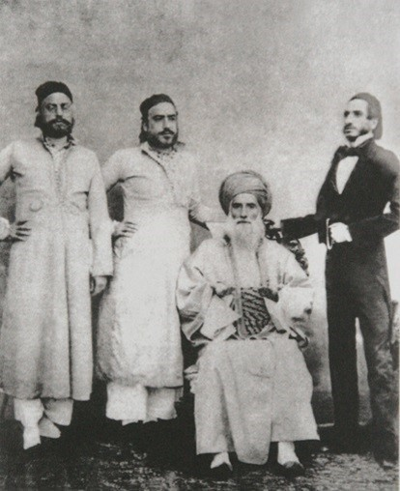
Source D
Sassoon Family
In 1844, after David Sassoon had arrived Guangzhou, within 5 years a solid commercial base was set up by the Sassoon family along the coast of China. When their office was set up in Hong Kong in 1857, almost all the Jews in the Mainland and Hong Kong were working under the Sassoon Family. His son Arthur Sassoon was one of the founders of The Hong Kong and Shanghai Bank Corporations (HSBC). Another son of David Sassoon, Frederick Sassoon, was commissioned into the Legislative Council.

Refer to Source 7 in Part B of this learning resource pack

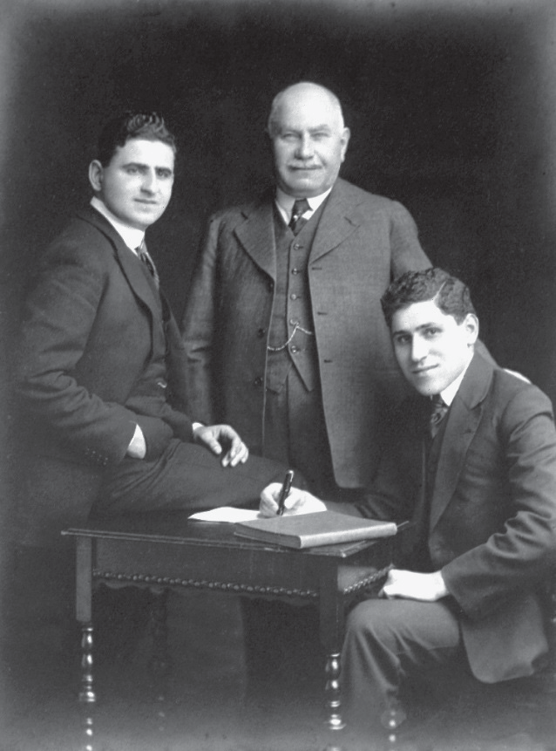
Source E
Kadoorie Family
Elly Kadoorie (in the middle of the photo) had worked under Sassoon Family in Bombay, Hong Kong and Northern China. In the 1880s, Elly Kadoorie returned to Hong Kong and started his own broker business. When his brother Ellis Kadoorie arrived Hong Kong in 1883, they invested and established several core family businesses like the China Light & Power Company (CLP) and the Peninsula Hotel. Later his elder son Lawrence Kadoorie (on the right) took over the family business, while another son Horace Kadoorie (on the left) concentrated on the family’s philanthropic efforts, such as the Kadoorie Agricultural Aid Association.

Refer to Source 8 in Part B of this learning resource pack

75

1) Study Sources D and E and then answer the following question.
How did the Jews foster the development of Hong Kong? Explain your answer with reference to Sources D and E and using your own knowledge.
(Suggested answer)
The success of the Sassoon family invited more Jews to invest in Hong Kong and some of them took part in the Legislative Council. (Source D). Apart from investing in public business such as the China Light & Power Company (CLP), the Kadoorie family also participated in charities including Kadoorie
Agricultural Aid Association. (Source E) In 1890, Emanuel Raphael Belilios, a Jewish merchant donated to establish girls government school and provided scholarship for secondary school students. The school is still named after him today. (own knowledge)

Today, Sassoon and Kadoorie families have a lot of historical footprints in Hong Kong.
Try to search for other information (such as the names of streets, facilities, agencies, etc.) that are related to them, report to group members and write down notes from classmates’ presentations.

(Suggested answers)

Related to Sassoon’s | Related to Kadoorie’s
For reference:  David Sassoon & Co.: First they engaged in trade, later invested in real estate, shipping and banking.  Ohel Leah Synagogue: Built in 1901, it is the only existing synagogue in China. Sassoon’s Brothers donated land to finance the construction of the church in dedication to their mother Leah Elias Sassoon.  Sassoon Road: The road is located in Southern District of Hong Kong Island, linking the area around Queen Mary Hospital at Pokfulam Road in Western Highlands and Sandy Bay near Victoria Road. | For reference:  Kadoorie Farm and Botanic Garden: Founded by Kadoorie brothers in 1951, it engaged in research and development of agricultural technology.  Kadoorie Hill: There are two major roads, one of which is named Kadoorie Road.  Sir Ellis Kadoorie Secondary School : It was established in 1890 with funding from  the Kadoorie family. In 1916, Hong Kong government took over the management of the school.

76

Topic 2 Jewish life in Hong Kong and their contribution

- How did the Jews settle in Hong Kong?
- How did the Jews contribute to Hong Kong?

How did the Jews settle in Hong Kong?
1

What are the Jewish festivals? How are they different from the Chinese traditional festivals? Search for relevant information and share with your classmates.

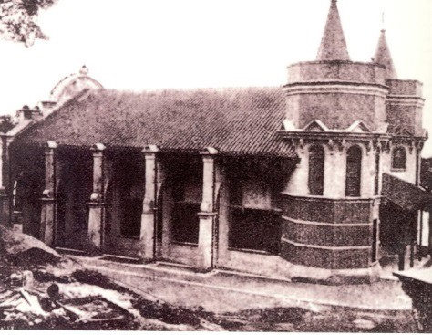
Source A
Ohel Leah Synagogue

The Ohel Leah Synagogue was built in 1902, it was the earliest formal Synagogue in Hong Kong. Thanks to the donations of Jacob Sassoon and his brothers for the contribution to the Synagogue, the Synagogue was named after their mother, Leah, as an appreciation to their contribution. Despite its colonial outfits, the inner structure was in classical Sephardic Jewish style as most of the Jews in early Hong Kong were Sephardi Jews from Baghdad. The Synagogue was separated by gender with the second floor restricted to females only and the ground floor was males only. It is arranged under the rules that females and males should sit separately. Except being taken over during the Japanese occupation, it has been one of the very few Synagogues kept as a hall of prayer in Asia.

Refer to Source 4 in Part B of this learning resource pack

77

Year | Population
1871 | 65
1881 | 71
1897 | 163
1911 | 231
1921 | 126

(Suggested answer)
Source B Statistics of Jewish population in Hong Kong from 1871-1921
Source: adapted and translated from 丁新豹、盧淑櫻：《非我族裔：戰前香港的外籍族群》( 香港：三聯書店，2014 年 )

According to Sources A and B, identify TWO reasons why the Synagogue was built.
Jacob Sassoon and his brothers donated in the name of their mother, Leah. (Source A) As there was a growing Jewish population in Hong Kong, there was a need to build a permanent hall for prayers. (Source B)

The Jews uphold their own tradition and work hard to maintain it. Apart from the above
buildings, and from your own knowledge, are there any other buildings in Hong Kong that reflect the Jewish insistence on their own tradition? Explain your answer with one example.
In 1855, Ellis Kadoorie bought land at Wong Nai Chung to build a Jewish cemetery. It was granted by the government in 1857. The Jews have a unique funeral tradition that the cemetery only buries the Jews. Building their own cemetery reflects that the Jews attach importance to their own culture.
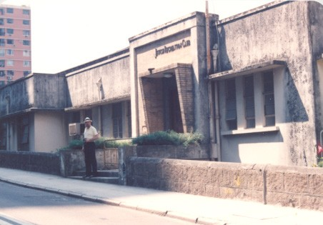
To know more…
The Jewish Recreation Club (JRC) was established in 1905. At the very beginning, it was located in a one-room building, and its extension started in 1909 after received donations from Elly Kadoorie. To enhance the interaction between different ethnic and cultural groups, the Club opened to Jews of different nationalities and communities with different cultural backgrounds. The Club also provided recreational facilities such as tennis, but shifted to relief activities for Jewish refugees in Hong Kong under the warring international situation in the 1930s. Two weeks after the Japanese had occupied Hong Kong in December 1941, the Recreation Club was forced to close down. It was not in service until its reconstruction in 1949.
Refer to Source 2 in Part B of this learning resource pack
78

Source C Questions and answers about the Jewish New Year (Rosh Hashanah)
Q: Is Rosh Hashanah also two days in Israel?
A: Yes, even in Israel Rosh Hashanah is kept for two days and both days are equally important.
Q: How many blasts of the shofar are heard?
A: On Rosh Hashanah, there are a hundred blasts of the shofar. The most important is the first set of thirty.
Q: What other customs are there before Rosh Hashanah?
A: There is a custom to give charity, take a haircut and shave.

Source: Ohel Leah High Holidays Guide 5779/2018
https://ohelleah.org/ols/wp-content/uploads/2018/08/HH-booklet-5779-Revised.pdf

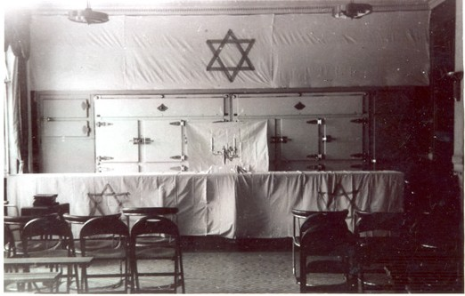
Source D Jewish New Year services in Hong Kong

From the photo, we can observe how the Synagogue is decorated during the Jewish New Year: cloth marked with the Star of David is placed on the wall and the table. In the middle of the table, there is also a Menorah placed. Both the Star of David and the Menorah are important symbols for Judaism.

Refer to Source 1 in Part B of this learning resource pack

1) Even far from their homeland, the Jews in Hong Kong are still celebrating New Year in their own tradition. According to Sources C and D, complete the table below about the traditions of the Jewish New Year in Hong Kong.

Source C | Source D
Jewish New Year lasts for two days. | The curtain of David’s Star is placed in the pray room of the Synagogue.
There are blasts of the Shofar. The most important is the first set of thirty. | A Menorah placed in the middle of the table.
To give charity, have a haircut and shave. | Chairs arranged in rows for prayers.

79

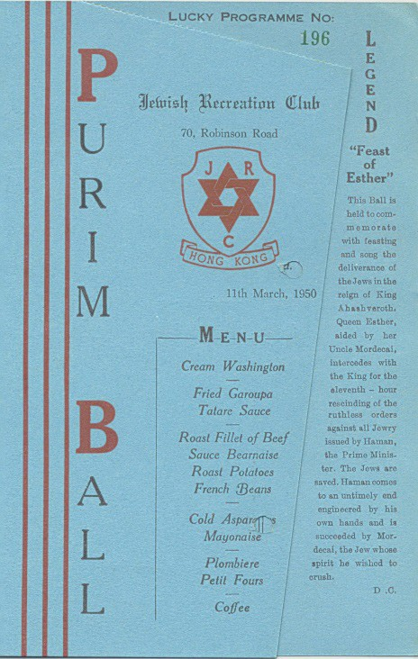

To know more…

Another Jewish festival - Purim
According to the Book of Esther, Purim is to remember the Jews who were freed from the plot of the ancient Persian vizier Haman the Agagite, who wanted to exterminate the Jews in Persia. Jewish communities all around the world celebrate this festival every year. The Purim ball held in the Jewish Recreation Club in 1950 was the first social event held in the Club after
its reconstruction. From the menu above, we can know the importance of Purim to the Jews by how bountiful the dishes are.

Refer to Source 3 in Part B of this learning resource pack

80

How did the Jews contribute to Hong Kong?
2

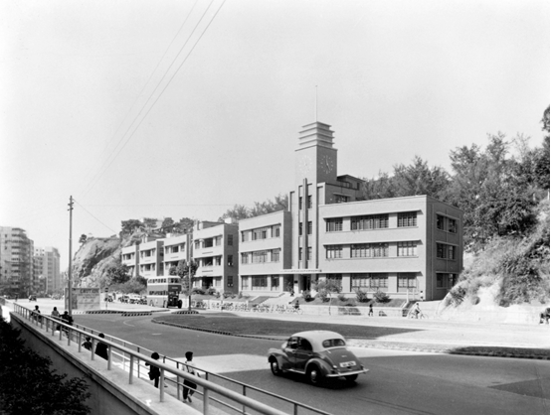
Source A
China Light & Power Company Syndicate and the Kadoorie Family

China Light & Power Company Syndicate was established by the Kadoorie Family in 1901. It aimed at providing electricity to Kowloon and New Territories. In order to overcome the rapidly increasing population in Kowloon, decision was made for a new head office located in 139-147 Argyle Street, Ho Man Tin, Kowloon. The foundation of the new Head Office was laid in 1938, and the construction was completed in 1940. Red bricks were used for the construction. It was a five- storey, modernist-style building with a simple bilateral symmetry design. The clock tower located at the center was the main characteristic of the building. It was classified as a Grade I historic building in Hong Kong.
Refer to Source 19 in Part B of this learning resource pack

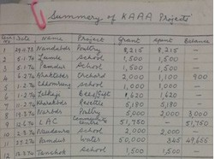
Source B
Expense summary of Kadoorie Agricultural Aid Association (KAAA) Project

Kadoorie Agricultural Aid Association
(KAAA) was founded by Sir Horace Kadoorie and Lord Lawrence Kadoorie in 1951.The
main tasks of KAAA included agricultural training, interest- free loans, constructing and promoting farms, demonstrating
different types of farming and herding
methods, and breeding improvement work.
From the Summary of KAAA Project, we
can observe that the project involved many items, including poultry, orchard, vegetable plantation and even bees keeping.

Refer to Source 15 in Part B of this learning resource pack

81

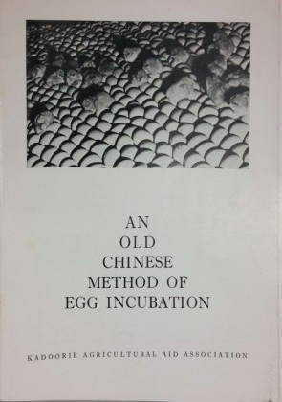
Source C
Cover of agricultural teaching material for Gurkhas in Hong Kong

To ensure the Gurkha ex-servicemen could be merged into society and be able to support themselves economically, the British Army invited Sir Horace Kadoorie to provide agricultural training for the soon retiring Gurkhas.
When providing such training, the Kadoorie Agricultural Aid Association (KAAA) paid much attention to local conditions and contexts. For example, as shown in the cover, the agricultural training material on an old Chinese method of egg incubation with low cost was prepared for Gurkhas.

Refer to Source 17 in Part B of this learning resource pack

(Suggested answer)

According to Sources A, B and C, what did the Kadoorie family contribute to Hong Kong? Explain your answer.

Source | Evidence/examples | Contributions
A | Kadoorie family established China Light and Power Company (CLP) in 1901. | Provided electricity for Kowloon and the New Territories.
B | Kadoorie Agricultural Aid Association was founded in 1951 by the Kadoorie family. | Provided agricultural training, interest-free loans, built and  promoted farming, demonstrated various methods of farming and carried out breeding improvement work.
C | The army invited Kadoorie to give agricultural training to those retired Gurkhas. | Facilitated the Gurkhas to merge with society to ensure their livelihood  after retirement.

82

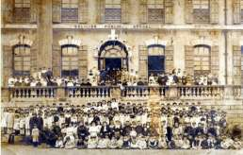Source D

A brief history of a girls’ secondary school in Hong Kong

A school photograph in the 1900s
Mr. Belilios was best remembered for being a great philanthropist. Before he made the $25,000 donation to enable our school to have a new 3-storeyed building, he had donated $5,000, one third of the total costs for setting up the Alice Memorial Hospital, which served as one of the major teaching hospitals for students of the Hong Kong College of Medicine for Chinese (which later became the Faculty of Medicine of the University of Hong Kong).
With a view to promoting the welfare and education of Chinese girls who were driven to crimes and prostitution by poverty, Mr Belilios also made available the funding for establishing a probation home for girls. There was and is also an abundance of scholarships established with Mr Belilios' donations either during his lifetime or upon death. They have enabled needy students to pursue education at the universities.

Source: Belilios Public School webpage (www.belilios.edu.hk)

According to Source D, list the contributions Mr. Belilios had made to Hong Kong.

  - Donated to start a school

  - Donated to start a hospital

  - Set up probation home for girls

  - Set up scholarships

83

In Pursuit of Aspiration – History of Different Ethnic Groups in Hong Kong and their Contribution to the Development of Hong Kong
Extended
Learning
Activity

I. Is “Nathan” II. What is the source of the name of a electricity?
street only?
III. An extraordinary IV. Where to search for farm: How did the the Jewish imprints Kadoorie Farm promote in Hong Kong?
“Self Help and Helping Others” ?

Extended learning activity (1): Is “Nathan” the name of a street only?
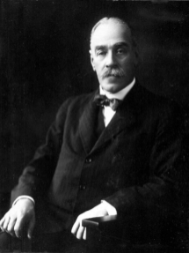
Sir Matthew Nathan
Sir Matthew Nathan was the first and the only Jewish Governor of Hong Kong, which was an important milestone for the development of Jewish community in Hong Kong under British colonial rule. He was born in London in 1862. He variously served as the Governor of Sierra Leone and Gold Coast in Africa, and was appointed as the Governor of Hong Kong in 1904. Nathan became the Hong Kong Governor at the age of 42. Nathan pioneered the early development of Kowloon, and pushed ahead the Kowloon-Canton Railway project. Whilst Governor of Hong Kong, Nathan served as the Honourary President of the Ohel Leah Synagogue (the first Jewish Church in Hong Kong) and also helped the community extend the lease on the Jewish Cemetery. He left Hong Kong in 1907 and died in England in 1939.

Refer to Source 6 in Part B of this learning resource pack

Answer the following questions with reference to Sources A and B.

Source A
The following is adapted from a news article published from The China Mail in 1907. It is about what Sir Nathan said before he left Hong Kong to become the governor of Natal in South Africa.

SIR MATTHEW NATHAN GOES TO NATAL
Sir Nathan highly praises the Chinese and unhesitatingly pronounces them good people. One of the chief sources of regret at his departure is that he will have to leave the work of constructing the Kowloon-Canton railway unfinished so far as he is concerned. In this first railway of ours he has taken more than a fatherly interest and he hoped to witness its completion. But it is well under way now and Sir Matthew Nathan is happy at that. At the present rate of progress, he thinks the line should be ready for work in about three years. This will come as good news.

84

In Pursuit of Aspiration – History of Different Ethnic Groups in Hong Kong and their Contribution to the Development of Hong Kong
Source B The following is adapted from an article about Governor Nathan.

After becoming the Governor of Hong Kong in 1904, Sir Matthew Nathan made great contributions to the development of Kowloon. He suggested leveling the hill in the north of Austin Road so as to connect Robinson Road and Gascoigne Road. Meanwhile, the road was widened.
Since there were some roads in Hong Kong Island and Kowloon Peninsula shared same name, the government decided to rename some of the roads in Kowloon. To recognise the contribution of Governor Nathan to the development of Kowloon, Robinson Road in Kowloon was renamed Nathan Road. Having reached an agreement with the Chinese government concerning the construction of Kowloon-Canton Railway, the Hong Kong government started reclamation in Tsim Sha Tsui, while Chatham Road and Salisbury Road were also built. With the complete commission of the Kowloon- Canton Railway on 5 October 1911, Hong Kong enjoyed a closer tie with the mainland. There was a temporary railway station in Tsim Sha Tsui and Hung Hom until the main building of Railway Station was built in 1916. It marked the commencement of a new era of public transportation.

Source: Adapted and translated from Think Hong Kong 〈彌敦道百年變遷〉
http://www.thinkhk.com/article/2017-07/11/21927.html

Source A—Discussion Questions | Source B—Discussion Questions
Which type of source—primary or secondary— does Source A belong to? | Which type of source—primary or secondary— does Source B belong to?
Identify the issue that caused Governor Nathan’s feeling of regret. | Infer one contribution that made by Governor Nathan to Hong Kong.
Why did he feel so regretful? | Suggest one reason for renaming ‘Robinson Road’ to ‘Nathan Road’.
Infer one contribution that made by Governor Nathan to Hong Kong. | Identify one contribution that made by Governor Nathan in fostering the connection between the Mainland and Hong Kong.

(Suggested answers)

Source A | Source B
It is a primary source, as the source was extracted from a newspaper that published at that time, and the news article was directly reporting the situation at that time. | It is a secondary source, as the source was adapted from an article concerning the contributions of Governor Nathan.
It was because Governor Nathan could not witness the launch of Kowloon-Canton Railway Corporation (KCRC) before he left his office. | Governor Nathan improved the transportation of Hong Kong, as he decided to widen and extend roads.
It was because Governor Nathan actively engaged in the construction of the railway. | As Governor Nathan made extraordinary contributions to the development of Kowloon, so the road was re-named in memory of his contributions.
Governor Nathan’s effort improved the transportation of Hong Kong and the KCRC benefited the communication between the Mainland and Hong Kong. | Governor Nathan played an active role in the planning and construction works of the KCRC. This benefited the communication between the Mainland and Hong Kong in the long run.

85

In Pursuit of Aspiration – History of Different Ethnic Groups in Hong Kong and their Contribution to the Development of Hong Kong

Extended

Learning
Activity

Extended learning activity (2): What is the source of electricity?
- Based on what you have learnt in the lesson, which of the following energy company is related to a Jewish family?
  - Hongkong Electric Company
  - China Light and Power Co Ltd
Read the following photos about an energy company in Hong Kong, and complete the table.

 | The following picture shows the first power plant located in Chatham Road, Hung Hom. It was built and commenced service in 1903. | The following picture shows the power plant in Hok Yuen, Kowloon, in 1925.
 | 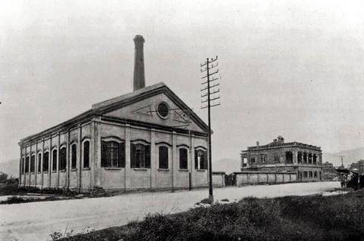 | 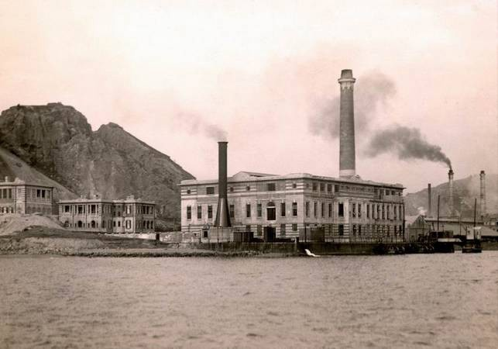
 | Then and now: Located in nowadays Chatham  Road and the roundabout on Princess Margaret  Road . The plant was relocated to Hok Yuen, Hung Hom in 1921. | Then and now: Today’s Laguna Verde , Hung Hom. Do you know about the story of the plant during the Japanese occupation?
 | The following picture shows the headquarter of an energy company, which was completed in 1940.
 |  | Find a picture of today’s CLP headquarter, and stick it here.
 | Then and now: Locates in nowadays Argyle  Street, Ho Man Tin, Kowloon . | The historical origin of the headquarter is closely related to the high-class residential area in Kadoorie Hill .
Source: Hong Kong Heritage Project
https://www.hongkongheritage.org/Pages/picture_gallery.aspx?F1JHFosXlJv2cuRBxeowdv3kQcI+ d0hTVlBuvjGXo67R5B3MdswK7Q==
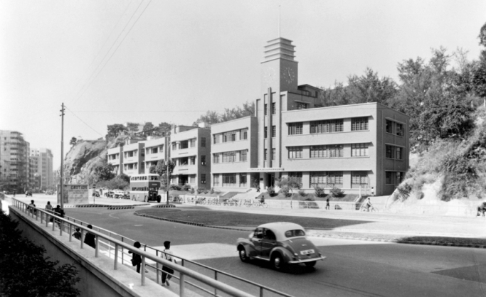
86

Extended
Learning
Activity
In Pursuit of Aspiration – History of Different Ethnic Groups in Hong Kong and their Contribution to the Development of Hong Kong

Suggest watching the video clip ‘The establishment of the CLP’ (The 32nd episode of Hundred People of Hong Kong), and complete the following table.
(Suggested answers)

For details, please watch the video clip about the China Light and Power Co. Ltd.

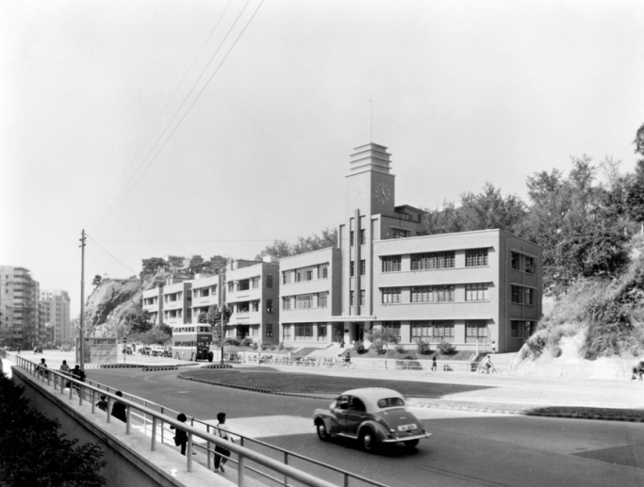

 | Name of the entrepreneurs | Elly Kadoorie, Lawrence Kadoorie and Horace Kadoorie
 | Ethnic groups | Jews
 | Did they start their enterprise in Hong Kong? | Yes
 | Name of their enterprises | CLP group, the Hongkong and Shanghai Hotels Limited. Kadoorie Agricultural Aid Association (KAAA)
 | Situation during Japanese occupation of Hong Kong | Elly Kadoorie was ordered to destroy the power generator. He then left Hong Kong for the mainland.
 | How did their enterprises contribute to Hong Kong’s development? | - The CLP Group provides energy to Hong Kong.  - The Peninsula Hotel hosts numerous visitors from all over the world.  - KAAA provided necessary assistance to villagers in the New Territories.

Extended learning activity (3): An extraordinary farm: How did the Kadoorie Farm promote “Self Help and Helping Themselves”?

87

In Pursuit of Aspiration – History of Different Ethnic Groups in Hong Kong and their Contribution to the Development of Hong Kong

Stretching across Tai Po and Yuen Long, the Kadoorie Farm and Botanic Garden, which encompasses 148 hectares, is an environmental education center. Devoted to research and develop agricultural technology, the former Kadoorie Agricultural Aid Association (K.A.A.A.) helped the people who came to Hong Kong after 1949 to sustain themselves by practicing agricultural works.

What personal reason encouraged Elly Kadoorie to develop charity works?
How did the situation in Hong Kong at that time contribute to the development of Kadoorie family’s charity plans?
How did the Kadoorie Agricultural Aid Association put the philosophy of 'Helping People Help Themselves' into practice?

You may read the following sources or watch the video clip to deepen your understanding on the Kadoorie Agricultural Aid Association.

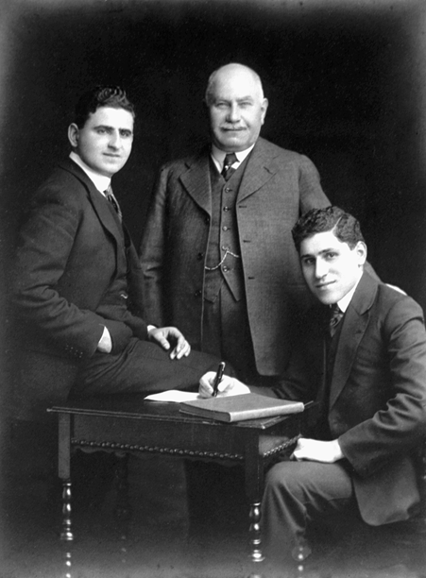Source A The following passage describes the operation of Kadoorie Agricultural Aid Association (KAAA) and the photo shows Sir Kadoorie and his sons.

The Kadoorie brothers, Sir Horace (left) and Lord Lawrence (right),sowed the seeds of the Kadoorie Farm and Botanic Garden(KFBG) when they founded the Kadoorie Agricultural Aid Association(KAAA) in 1951. In 1941, there were 1.25 million people living in Hong Kong. By the end of the Japanese occupation in 1945, the population had shrunk to about 600,000. In that same year the flood of people fleeing the Civil War on the Mainland began. By the end of 1946 the population of Hong Kong had swollen to 1.5 million. Horace and Lawrence Kadoorie wanted to help these destitute arrivals become self-supporting and independent; they wanted to help them regain their dignity and find security in their new lives in Hong Kong. Since most of the Chinese were farmers, an ambitious agricultural aid project was conceived, thus, the Kadoorie Agricultural Aid Association (KAAA) was formed on 28 September 1951.
The founders were Horace and Lawrence Kadoorie, Norman Wright and Woo Ting Sang. In 1956, the KAAA established an experimental and extension farm at Pak Ngau Shek (the present site of KFBG) as a centre to demonstrate effective and profitable crop production and animal husbandry techniques, to improve livestock breeds and to train local farmers and Hong Kong-based Gurkha soldiers in farming so that they could have income when they returned home to Nepal. Special hybrids of pigs and chickens were selectively bred, and these made a big contribution towards food security in Hong Kong. The result was not only a revitalisation of the local economy, but also of the hopes and dreams of the people of the New Territories and Outlying Islands.

Refer to Source 8 in Part B of this learning resource pack

Source: adapted from ‘About us – History and Heritage’ from Kadoorie Farm & Botanic Garden
https://www.kfbg.org/en/history-and-heritage/the-early-days/

88

In Pursuit of Aspiration – History of Different Ethnic Groups in Hong Kong and their Contribution to the Development of Hong Kong
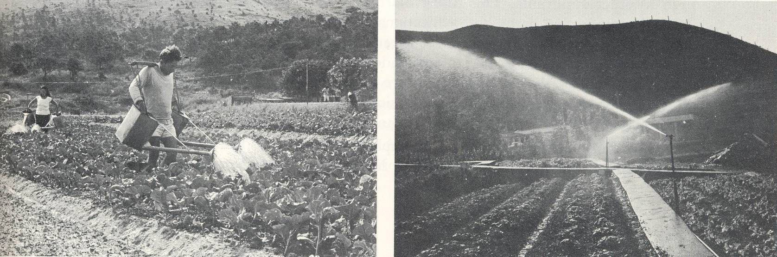
Source B
The following pictures shows the KAAA-invented sprinkle irrigation system.

Source: Hong Kong Heritage Project
https://www.hongkongheritage.org/Pages/picture_gallery.aspx?dh4U5h1j14WVrdGiBM5Y4vbS/ gdsjOl79B1q0Lg1/hQ78WH+zHPD1g

Why did Kadoorie family develop charity work?
It was because Sir Horace Kadoorie and Lord Lawrence Kadoorie wanted to help those people who moved to Hong Kong after the Second World War to achieve a self-supporting and independent life.

How did the situation in Hong Kong at that time contribute to the development of Kadoorie family’s charity plans?
The large number of amount of people who moved to Hong Kong after the Second World War made the charity plans more necessary than before.

How did the Kadoorie Agricultural Aid Association put the philosophy of 'Helping People Help Themselves' into practice?
The Association would not provide agricultural goods to those who joined the scheme. Instead, the Association provided technical support and other necessary resources to participants so as to increase their yield.

Why did the Kadoorie family decide to develop agriculture as a means to help the postwar arrivals in Hong Kong?
This was mainly due to the background of those who moved to Hong Kong after the Second World War. Most of them were originally farmers before they arrived Hong Kong.

Identify one characteristic in assistance provided to farmers by the KAAA.
The assistance provided by the KAAA was mainly related to farming technology. The KAAA established an experimental farm and invented sprinkle irrigation system. It proved that the assistance was mainly related to farming technology.

How, in your opinion, did the KAAA help the farmers and the Hong Kong society?
Farmers: The assistance provided by the KAAA increased the yield of the farmers and their income. HK society: The assistance provided by the KAAA contributed to better food security and helped the development of the New Territories.

89

In Pursuit of Aspiration – History of Different Ethnic Groups in Hong Kong and their Contribution to the Development of Hong Kong

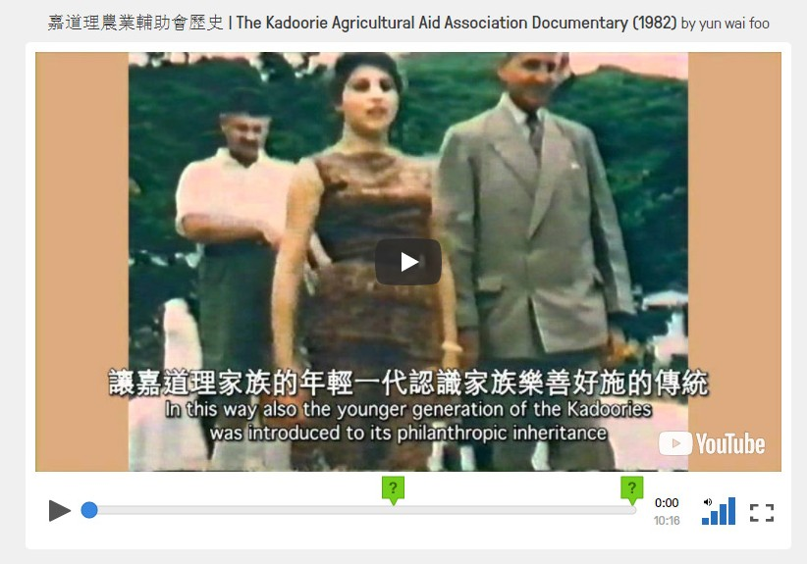Source C

The Kadoorie Agricultural Aid Association Documentary with pop up questions for e-learning

The documentary describes a large number of people from the mainland who rushed to Hong Kong because of the unstable political situation in the mainland in the late 1940s. They scattered in the New Territories and lived mainly on farming. In view of this, the Kadoorie brothers, Lawrence and Elly, established the KAAA in 1951 to help the farmers live on their own and help others as well.

  - How did Kadoorie Agricultural Aid Association (KAAA) help farmers improve their productivity? (05’43”)
It provided materials for constructing irrigation network and demonstrated more farming techniques to Hakka women, gave basic farming tools such as two hundred sets of threshing machines and over two thousand sets of sprayers loaded with insecticides and so on.

  - How did KAAA contribute to the agricultural development in Hong Kong? (10’12”)
It had contributions in irrigation for farming, poultry farming and construction of roads and paths.

Source：https://edpuzzle.com/media/5a2740aa6dfd4140ffd02d96

90

In Pursuit of Aspiration – History of Different Ethnic Groups in Hong Kong and their Contribution to the Development of Hong Kong

According to the video clip in Source C, was the emergence of KAAA a turning point in Hong Kong’s post-war agricultural development? Complete the table below and answer the question which follows.

(Suggested answer)

 | Before the founding of KAAA | After the founding of KAAA
Poverty alleviation | Many refugees from the mainland had no home. | KAAA helped the new arrivals to establish their farms. Hundreds of these families were settled in the newly established sites.  They joined the experimental farms to practice farming and keep livestock.
Irrigation | Without any modern irrigation network. | The settlers constructed the irrigation network with KAAA materials.  Irrigation improved crop yield and increased the farmers’ earnings.
Agricultural Technology | Agricultural technology was lagging behind.  Exploding fire crackers used to be the traditional way to frightening off crop devouring pests. | In 1955 Horace Kadoorie started giving away agricultural tools such as 200 threshing machines and more than 2000 of the sprayers loaded with insecticides and so on. While labour cost was lowered, the effectiveness  of agricultural production was raised. Having practiced farming and livestock keeping in terrain area in Pak Ngau Shek experimental farm, the KAAA learned a very good lesson from it. This experience was, in turn, passed to other farmers, and ultimately benefitted the agricultural development of Hong Kong.
Livestock Technology | At that time, the local strain of Cantonese pig was generally physically unattractive and not good for eating. | With the help of KAAA, the healthiest local strain of pig was cross bred with imported animals. The succulent Pak Ngau Shek special was emerged.
Transportation | There were no roads in the settlers’ community and it was inconvenient for traffic. | The paths and tracks across the hillsides were surfaced with cement. These paths gave the settlers access to markets and their children to schools. The whole community  was brought closer together and linked more firmly to the life of Hong Kong.

91

In Pursuit of Aspiration – History of Different Ethnic Groups in Hong Kong and their Contribution to the Development of Hong Kong

The emergence of Kadoorie Agricultural Aid Association was / was not a turning
point in Hong Kong’s post-war agricultural development, because

(The following answers are for reference only.)
After the Second World War, a lot of new arrivals coming from the mainland to Hong Kong were peasants. They had difficulties to find a job in Hong Kong and suffered from poor livelihood. However, the Kadoorie Agricultural Aid Association helped them establish their farms. Hundreds of these families were benefitted. Their livelihood gradually improved. Later, they joined the experimental farms to practice farming and keep livestock. The agricultural development was developed and gradually improved the life in villages. It was a turning point in Hong Kong's post- war agricultural development.

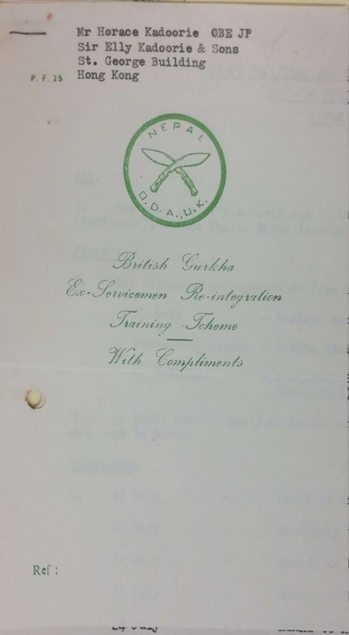Source D

British Gurkha Ex-Servicemen Re-integration Training Scheme Letterhead

Gurkha soldiers from Nepal was one of the important components of the British garrison of Hong Kong. Their main tasks included interception of illegal immigrants and maintenance of public order when being requested by the Hong Kong government. However, the Gurkha veterans, who received elaborate military training, might find themselves unable to adapt after retiring from the military as they were not trained for other vocations. Therefore, the British Army cooperated with the Kadoorie Agricultural Aid Association and introduced a British Gurkha Ex-Servicemen Re- integration Training Scheme. The photo above is the letterhead of the program.

Refer to Source 16 in Part B of this learning resource pack

92

In Pursuit of Aspiration – History of Different Ethnic Groups in Hong Kong and their Contribution to the Development of Hong Kong
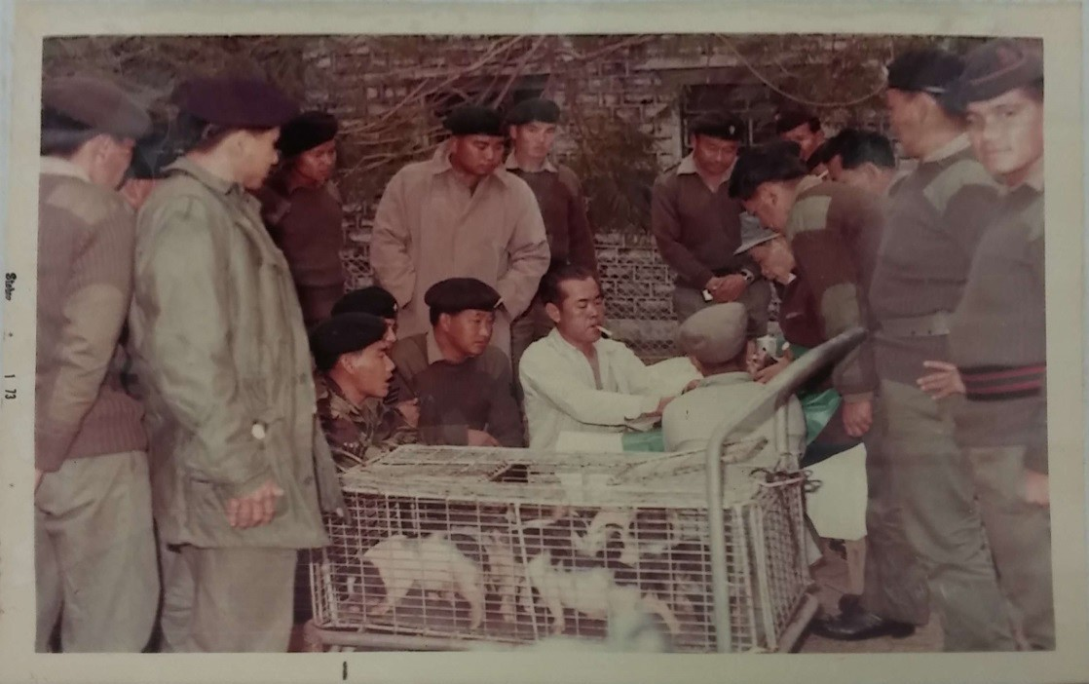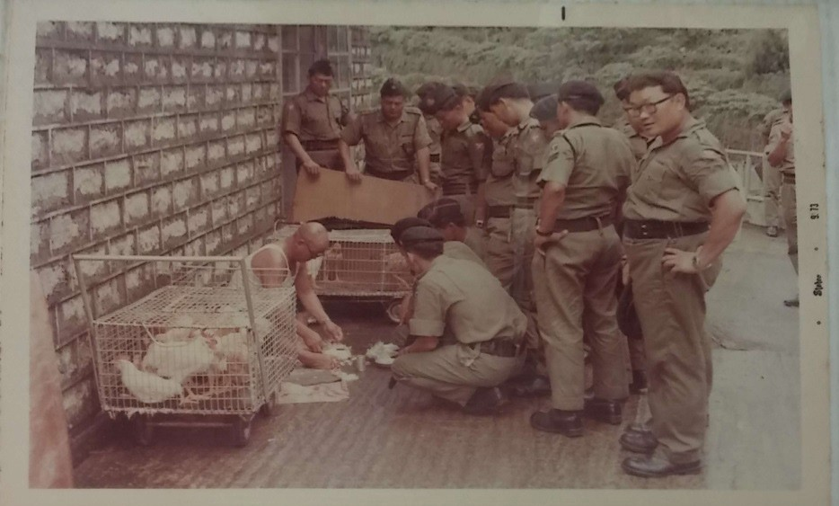
Source E This photo shows the Gurkha soldiers attending the Agricultural Training Course on piglets feeding.
Refer to Source 18.1 in Part B of this learning resource pack
Source F
This photo shows the Gurkha soldiers attending the Agricultural Training Course on chicken and duck feeding.
Refer to Source 18.2 in Part B of this learning resource pack

93

In Pursuit of Aspiration – History of Different Ethnic Groups in Hong Kong and their Contribution to the Development of Hong Kong
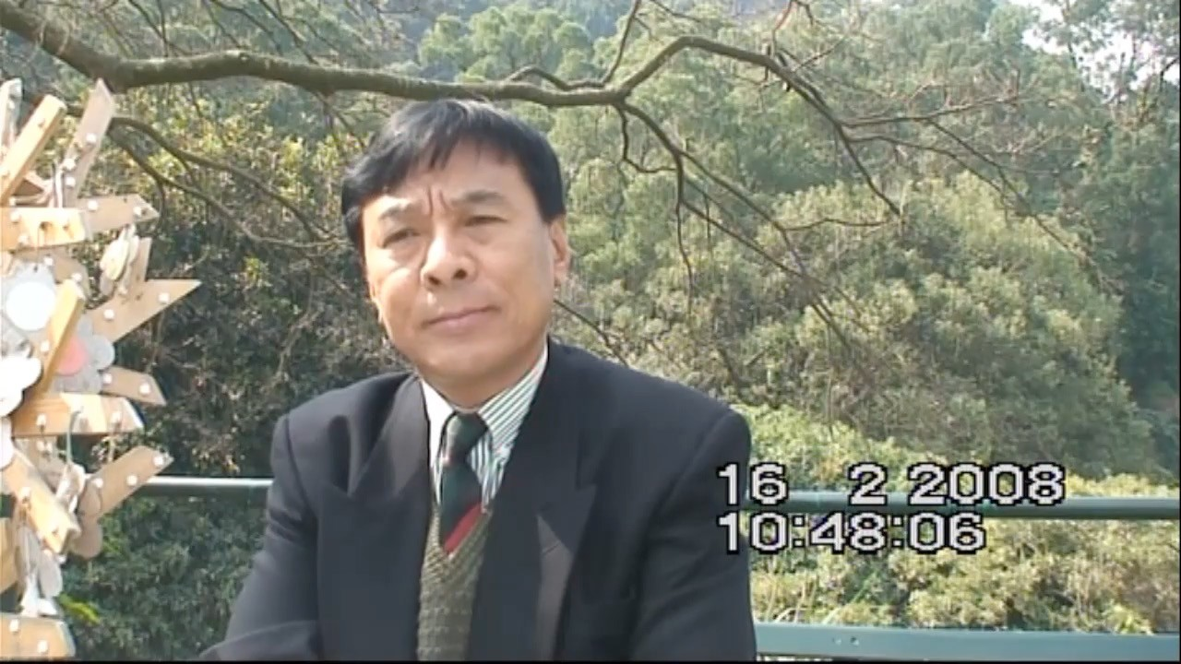
Source G
Recordings of Oral History interview of Sarbajit Gurung, a Gurkha ex-serviceman who benefitted from the training provided by The Kadoorie Farm.

For details, please watch the video clip about the interview to understand more about Sarbajit Gurung and the training provided by The Kadoorie Farm.
https://historye-learning.edb.hkedcity.net/video/source-52.mp4

Refer to Source 46 in Part B of this learning resource pack

(Suggested answers)

According to Sources D to F, what kind of training was mainly provided by KAAA’s ex-servicemen re- integration scheme?
Agriculture and cultivation training

According to Source G, how many ex-servicemen, as pointed out by Gurung, were benefited by the re-integration scheme?
There are approximately 7,677 ex-servicemen who received training.

How significant, in your own opinion, was the Kadoorie Farm’s ex-servicemen re-integration scheme? Explain your answers with reference to the sources provided.
Teachers may guide students to justify their answers with the clues provided in Gurung’s oral history interview, in which the interviewee mentioned that it was a trainer programme and the Gurkha ex- servicemen could earn a living through farming and cultivating when they were back home in Nepal.

94

In Pursuit of Aspiration – History of Different Ethnic Groups in Hong Kong and their Contribution to the Development of Hong Kong
Extended
Learning
Activity

Extended learning activity (4): Where to search for the Jewish imprints in Hong Kong?

Besides of the above mentioned, find out more about the Jewish’s building or other contributions. (Keywords: e.g. study and visit to the cemeteries of the ethnic minorities/ HSBC/ Cross-Harbour Tunnel/ The Peninsula Hong Kong.)

(Suggested answer)
1)

2)

3)
The construction of the Star Ferry, the Peak Tram and the Cross Harbor Tunnel are also under the responsibility of Jewish engineers.
The Kadoorie’s family established their business and prospered in Hong Kong. The CLP Power, the Peninsula, the Peak Tram and the Peak Tower, were owned or held by the Kadoorie family.
Mr. Belilios was a former director of the HSBC.

Watch a short video clip (Chinese only) to know more about the Ohel Leah Synagogue.

The Ohel Leah Synagogue
https://youtu.be/BPfWgbX04yc

- Browse the following websites to understand more about the New Year tradition of the Jews :

- Tashlich: A Rosh Hashanah Tradition
https://www.youtube.com/watch?v=JmlPBP3fC1k

- New Year tradition of the Jews
https://www.dw.com/zh/ 猶太新年大盤点 /g-17068723

95

In Pursuit of Aspiration
History of Different Ethnic Groups in Hong Kong and their Contribution to the Development of Hong Kong

Example 2
The Parsis

Personal, Social and Humanities Education Section Curriculum Development Institute, Education Bureau

Example 2
Learning
Objectives

The Parsis

To know more…

Understand the origins of the Parsis, famous Parsis in Hong Kong and their contributions
Understand different interpretations on historical events
Use collaboration skill, critical thinking skill, self-learning skill and information technology skill
Care for others
Appreciate the religion and culture of different ethnic groups Learn the values of perseverance and commitment

巴斯人 | The Parsis
羅旭龢爵士 | Sir Kotewall, R.H.
米泰華拉 | Dorabjee Naorojee Mithaiwala
麼地爵士 | Sir Mody, H.N.
J. H. 律敦治 | Ruttonjee, J.H.
香港大學 | The University of Hong Kong
律敦治療養院 | Ruttonjee Sanatorium
瑣羅亞斯德教（拜火教） | Zoroastrianism

Learning
^{and} Teaching
Materials

Topic 1: The origins of the Parsis in Hong Kong
Enquiry question 1
Who are the Parsis?
Why did they come to Hong Kong?

Pre-assessment: Matching

Topic 2: Contributions of the Parsis in Hong Kong

Enquiry question 2
What were the contributions of the Parsis in Hong Kong?

Extended learning activity (1)
Why is there a bust of Sir Robert Kotewell in the Hong Kong Central Library?

Extended learning activity (2)
Is there Zoroastrianism in Hong Kong?

An extract from the Hong Kong Government Gazette published in 1936 (Source A)
A news article from Overseas Chinese Daily News which was published in 1949 (Source B)
An extract from an article about Robert Kotewall (Source C)
An extract from the HKU website which described the Main Building and a photo of Mody (Source D)
Two pictures taken in the Main Building of the HKU (Source E)
An extract from the Huaqiao Ribao which was published on Feb 12, 1960 (Source F)
An extract from a description about the Ruttonjee Hospital (Source G) Profile of Dorabjee Naorojee Mithaiwala in Hong Kong (Source H) Origin of the Kowloon Ferry Company (Source I)
A picture of Star Ferry (Source J)

Photos of the bust of Sir Robert Kotewall

Worksheet for site visit

9988

Topic 1: The Origins of the Parsis in Hong Kong

Who are the Parsis? Why did they come to Hong Kong?

Pre-
assessment
Matching

B.
Dorabjee Naorojee
Mithaiwala
C.
Hormusjee Naorojee Mody
Match the names of Parsis, Robert Kotewall, Dorabjee Naorojee Mithaiwala, Hormusjee Naorojee Mody and Jehangir Hormusjee Ruttonjee, with their respective contribution.

A. Robert Kotewall
1. donated to the building of a sanatorium

2. donated to the expansion of the Main Building in HKU

3. served as a bridge between the colonial government
and the local Chinese people
D. Jehangir Hormusjee
Ruttonjee
4. founded the Kowloon Ferry Company

To know more…
The Parsis in Hong Kong mainly came from Bombay in the western coast of India. Their ancestors from Persia (Iran today) were Zoroastrians for generations. In the 7th century, the Da Zhi (the Arabs) defeated the Persians. Some Persians escaped to the western coast of India during the 8th to 10th centuries and gathered near Bombay…In the 18th century the British East Indian Company started their trade in Guangzhou and the Parsis came at the same time…
The British troops occupied Hong Kong Island on 26 January 1841. The first land sale was held in Macau in June. Four Parsi merchants, namely D. Rustonjee, H. Rustonjee , P. Cowasjee and F.Jamsetjee bought 7 pieces of coastal land. With improving trading condition, the Parsis gradually came and settled in Hong Kong.
Source: adapted and translated from 丁新豹、盧淑櫻：《非我族裔：戰前香港的外籍族群》( 香港：三聯書店，2014 年 )，頁 185-187

Topic 2: Contributions of the Parsis in Hong Kong
2

What were the contributions of the Parsis in Hong Kong?

Contribution of Parsi Chinese – Robert Kotewall
The following sources are related to Robert Kotewall. Please complete the personal profile of Robert Kotewall after reading the sources.

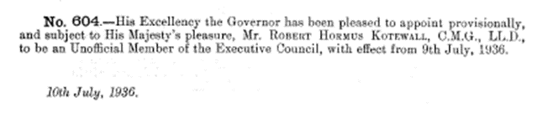
Source A The following is extracted from the Hong Kong Government Gazette, which was published in 1936.

Refer to Source 30 in Part B of this learning resource pack

Source B
The following is adapted from a news article from Overseas Chinese Daily News, which was published in 1949.

Affected by the Hong Kong-Canton General Strike, Hong Kong was unstable in 1925. Given the acute situation, Sir Kotewall suggested the Hong Kong government to request for loan from the London government so as to get through the crises. Following his suggestion, the Hong Kong government made good use of the loan and stabilized the Hong Kong economy. Not only did his efforts being recognized by the general public, Sir Kotewall was also praised by the newspapers and was named as ‘silver tongue’. He was further recognized by the British government as he was knighted in 1938. Served in numerous charity organisations like the Tung Wah Group of Hospitals, Po Leung Kuk, and the Hong Kong Society for the Protection of Children. Sir Kotewall pledged to provide adequate care for children. During the Japanese occupation period, Sir Kotewall determined to safeguard the interest of the local Chinese. Sir Kotewall had been suffered from heart disease since long. He died last night at his residence.

Profile of Sir Robert Kotewall
Ethnic | Parsi
Praise of newspaper | Silver tongue
Honour | Knighted by the British government in 1938
Year to join the  Executive Council | 1936
Charity organisations that served | the Tung Wah Group of Hospitals, Po Leung  Kuk, and the Hong Kong Society for the Protection of Children
Year of death | 1949

The following source is related to Sir Robert Kotewall, a Parsi.

Source C The following is about Robert Kotewall in Hong Kong from the 1920s to 1940s.
Up to 1940, Robert Kotewall, an official representative of local Chinese, had been served as a bridge between the government and the ordinary citizens, and, more importantly, the British and the Chinese. During the Hong Kong-Canton General Strike in 1925, Kotewall did not only help the government to maintain stability, he also visited Canton and negotiated with the Canton government. Due to his efforts, the transportation between the two cities resumed. After the strike, the Hong Kong economy was in recession. Representing the Hong Kong citizens, Kotewall negotiated with the British government for a large amount of loan. He made strong arguments in the meeting concerning the loan. While his renowned speech was known as ’30 million speech’ among the public, his eloquence won him the reputation of ‘silver tongue’. In the 1930s, in view of the poor economy, Kotewall suggested the government to lower the Rates. The government eventually changed the way to charge Rates, which benefited house-owners. Thus, Kotewall’s contribution was essential.

Source: extracted and translated from 劉智鵬：《香港華人菁英的冒起》( 香港：中華書局，2013 年 )

What was the role of Robert Kotewall between the local Chinese and the British?
Identify the contribution made by Robert Kotewall during the Hong Kong-Canton General Strike.
Why was Robert Kotewall known as ‘silver tongue’?

Complete the following table with reference to Source C:

Role of Robert Kotewall between the local Chinese and the British: | As an official representative of local Chinese, he had been served as a bridge between the government and the ordinary citizens
Contribution made by Robert Kotewall during the Hong Kong-Canton General Strike: | - Helped the government to maintain stability, and negotiated with the Canton government so as to resume the transportation between the two cities  - Represented the Hong Kong citizens after the strike, and negotiated with the British government for a large amount of loan  - Suggested the government to lower the Rates, which eventually benefited house-owners.
The reason for Robert Kotewall to be known as ‘silver tongue’: | Representing the Hong Kong citizens, he made strong arguments in the meeting negotiating with the British government for a large amount of loan. His renowned speech was known as ’30 million speech’ among the public. His eloquence won him the reputation of ‘silver tongue’

In Pursuit of Aspiration – History of Different Ethnic Groups in Hong Kong and their Contribution to the Development of Hong Kong
Extended
Learning
Activity

Extended learning activity (1): Why is there a bust of Sir Robert Kotewall in the Hong Kong Central Library?

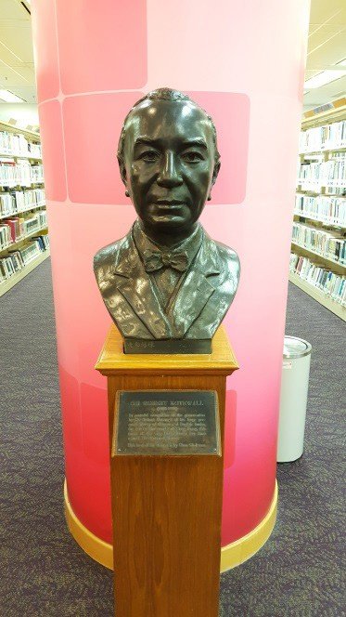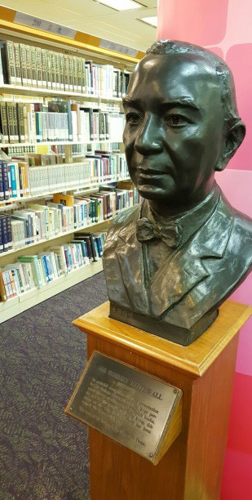In memory of Sir Robert Kotewall’s contribution to the promotion of education, a bust of Robert Kotewall was erected in the City Hall Public Library in Central and it is now located on the 9th floor of the Hong Kong Central Library in Causeway Bay. Sir Robert Kotewall had wide reading and had built up a valuable collection of Chinese and English books. His collection was bequeathed to the Hong Kong Government in 1957 and was housed in the City Hall Public Library for public use in 1962. A special fund was established by members of the Kotewall family to maintain and further strengthen the collection. The collection was subsequently transferred to the Hong Kong Central Reference Library for public use in 2001.

Source: Adapted from Introduction of ‘Kotewall Collection’, Hong Kong Public Library
https://www.hkpl.gov.hk/en/reference/special/kc.html;

Photos provided by a member of this project

104

Contributions of Parsis - Mody and Ruttonjee

Answer the following questions after reading passages related to Sir Hormusjee N Mody and Jehangir Hormusjee Ruttonjee.
The following sources are related to Sir Hormusjee N Mody, a Parsi.
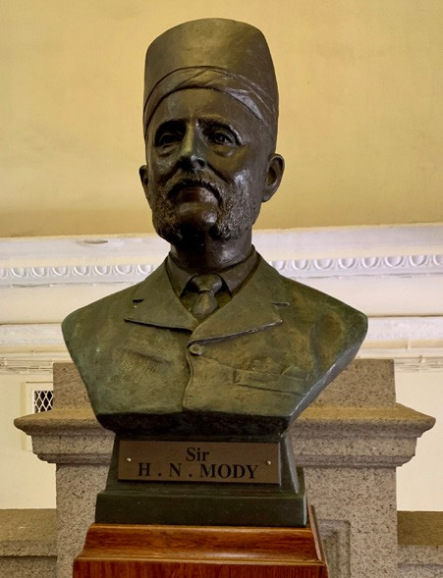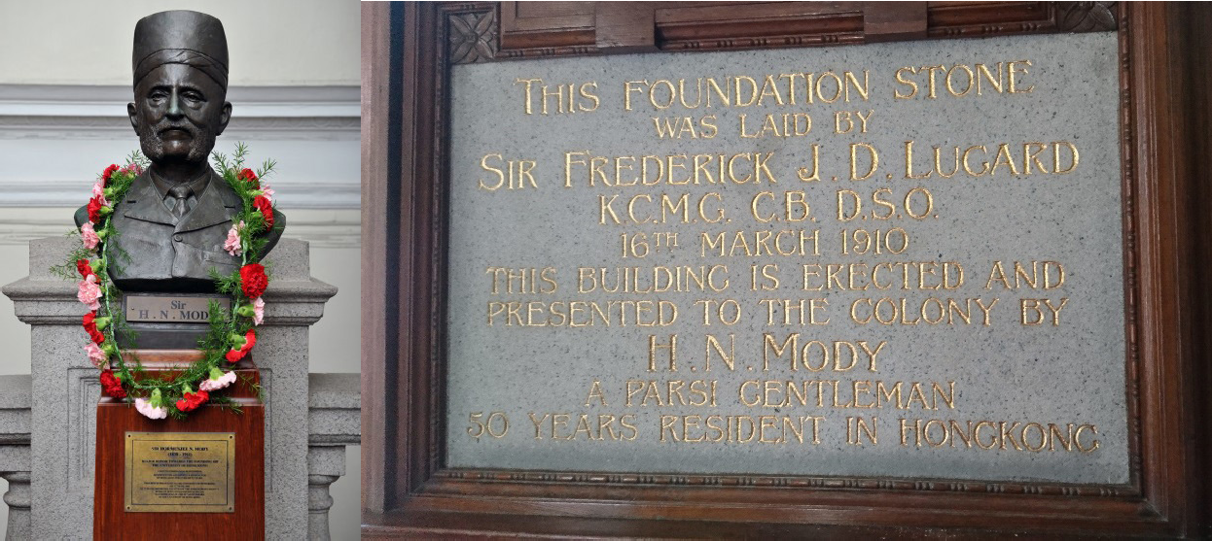
Source D
The following was extracted from the HKU website, which shows a picture of Mody and a description of the Main Building.

Sir Hormusjee N. Mody was a Zoroastrian businessman. Having noticed the plan of building a university soon became abortive, Sir Mody immediately provided financial support. At the Foundation Stone Laying Ceremony in 1910, Sir Mody presented a golden trowel to the then Governor, Sir Frederick Lugard, who used it to lay the foundation stone of the Main Building. He was later knighted and one could find a bronze bust of Sir Hormusjee N. Mody on the main staircase.
Source: Adapted from a website about Main Building, The University of Hong Kong:
https://www.hkh.hk/visit/campusbuilding.php?m=heritage&t=dm&bdg=main
Source E The following pictures were taken in the Main Building of the HKU.

What is the importance of Sir Mody in the establishment of the University of Hong Kong?
Do you think the importance of Sir Mody was recognised by the Hong Kong government at that time?
Do you think the University is still paying respect to Sir Mody’s contributions nowadays?

The following sources are related to Jehangir Hormusjee Ruttonjee, a Parsi.
Source F The following was extracted from the Huaqiao Ribao, which was published on Feb 12, 1960.
Philanthropist Jehangir Hormusjee Ruttonjee died at the age of 81. Ruttonjee, C.B.E., J.P., was the chairperson of H. Ruttonjee & Son. Building of Ruttonjee Sanatorium proved his kindness and his devotion to charity works. It was so generous for him to donate 850,000 HKD so as to ensure the establishment of the Ruttonjee Sanatorium in early 1949. Later, in memory of his daughter, he donated 200,000 HKD for another sanatorium in 1956. Countless people were benefited from his charity works.

Source G The following was a description about the Ruttonjee Hospital.
Jehangir Hormusjee Ruttonjee (1880-1960) was a Parsi born in Bombay in 1880. He immigrated to Hong Kong in 1892, and later studied in Queen’s College. He took over his father’s business after his graduation. He was so enthusiastic in the prevention of Tuberculosis and established the Hong Kong Anti-Tuberculosis Association in 1948. Also, he donated 850,000 HKD to convert the Royal Naval Hospital to Ruttonjee Sanatorium, which specialized in the treatment for Tuberculosis victims. Last but not least, to support the Government’s Bacillus Calmette-Guerin campaign, the Hospital provided free Bacillus Calmette-Guerin vaccines for the citizens in order to lower the chances of children infection rate for the disease.
Refer to Source 32 in Part B of this learning resource pack

Which kind of charity did Ruttonjee focus on?
Do you think the Hong Kong government recognized Ruttonjee’s contributions?
What was the role of Ruttonjee-financed hospitals/sanatoriums in the Hong Kong medical system?

Complete the following table with reference to Sources D to G:

Name : | Sir Hormusjee N Mody | Jehangir Hormusjee Ruttonjee
Ethnic : | Parsi
Aspect of  contribution : | Education | Medical
Major contribution : | HKU Main Building | Ruttonjee Sanatorium

Contributions of Parsis - Dorabjee Naorojee Mithaiwala

The following sources are related to Dorabjee Naorojee Mithaiwala, a Parsi.

Year | Career/Business | Related information | Remarks
1852 | Came from Bombay | Worked in the Duddell Trading Company
1863 | Owned a bakery | Signed a contract with the military force for providing daily necessities  Made profit and invested in hotel business
1870 | Owned several high class hotels in Hong Kong and Kowloon
1880 | Provided ferry service to link up Hong Kong and Kowloon | Established Kowloon Ferry Company with four ferries | I n 18 9 5 , C h a t e r , a n Armenian, bought the company and renamed it Star Ferry

- According to Source H, how would you describe Mithaiwala’s business in Hong Kong?
資資資資資資資資資資資 (資
188)
Source H Profile of Dorabjee Naorojee Mithaiwala in Hong Kong
Source: adapted and translated from 丁新豹、盧淑櫻：《非我族裔：戰前香港的外籍族群》 ( 香港：三聯書店，2014 年 ) ，頁 188
Diversified including bakery, hotel business and ferry service.

What made Mithaiwala’s bakery a success?
He signed a contract with the military force for the provision of foods which had a steady market.
Source I
Origin of the Kowloon Ferry Company
After the conclusion of the Treaty of Beijing in 1860, the Hong Kong Government started the development of the newly-acquired Kowloon Peninsula to solve the problem of land-shortage in Hong Kong Island. The number of residents who commuted between Hong Kong Island and Kowloon steadily increased. In 1880, a Zoroastrian established the Kowloon Ferry Company to provide ferry service, with the company’s ferries all named with the word “star”. In 1895, Sir Catchick Paul Chater bought the company and renamed it Star Ferry. The ferry service enhanced the development of Kowloon, and strengthened its link with Hong Kong Island.
Refer to Source 31 in Part B of this learning resource pack

According to Sources H and I, name one of Mithaiwala’s contributions to Hong Kong. Explain your answer.
He established the Kowloon Ferry Company which provided ferry service between Hong Kong Island and Kowloon. It solved the traffic problem of the people moving between the two places.

According to Source I, what tradition did Chater preserve when he took over and developed the business of the Kowloon Ferry company?
All ferries of the Kowloon Ferry company were named with the word “star”. After Chater had bought the company, it was renamed “Star Ferry”. The “star” signature is preserved.

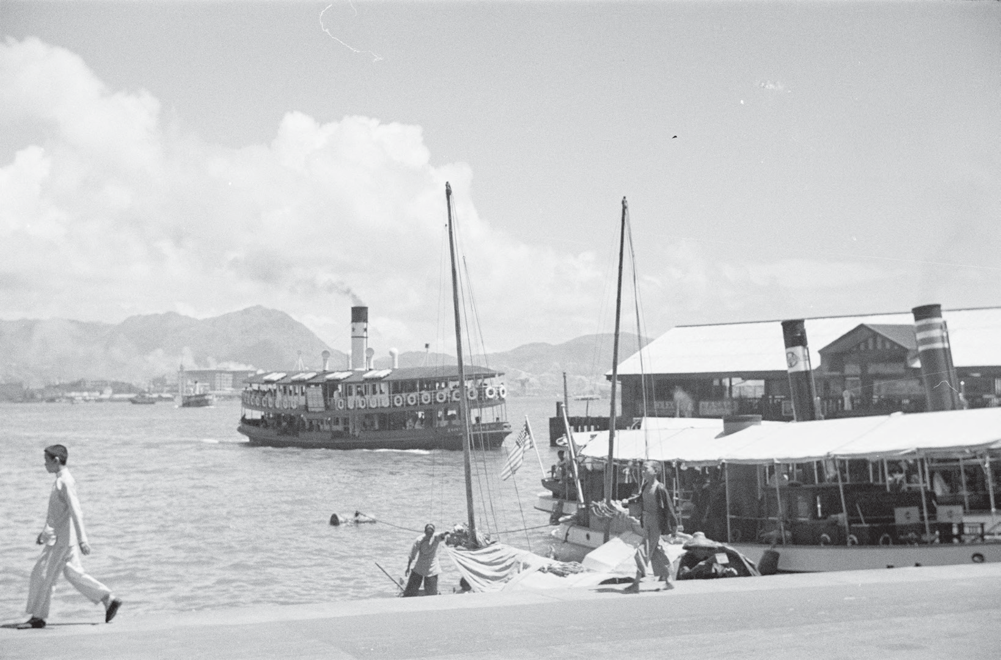
Source J The following is an old photograph of Star Ferry.

Source: Harrison Forman Collection, American Geographical Society Library, University of Wisconsin-Milwaukee Libraries
https://collections.lib.uwm.edu/digital/collection/agsphoto/id/16317/rec/4

According to Source J, in which period do you think the photograph was taken? Provide ONE clue to support your answer.
Suggested Answer
This photograph would have been taken in the late 1920s. The model of the Star Ferry in the photograph was similar to that of the Morning Star (1904-1928) of the Star Ferry Company. Besides, the Peninsula Hotel in Tsim Sha Tsui on the Kowloon Peninsula in the opposite side of the harbour could be seen. The hotel was being constructed from 1924 and opened in 1928. The two clues matched with each other about the period of the photograph.

Take a picture of today’s Star Ferry and compare it with the picture in Source J.

In Pursuit of Aspiration – History of Different Ethnic Groups in Hong Kong and their Contribution to the Development of Hong Kong
Extended
Learning
Activity

Extended learning activity (2): Is there Zoroastrianism in Hong Kong?

Reference materials:
丁新豹、盧淑櫻：《非我族裔：戰前香港的外籍族群》( 香港：三聯書店，2014 年) ，頁 185-193

Mogul, Rhea. (2020, August 16). Parsis in Hong Kong: what's the secret behind their growing population? South China Morning Post.
https://www.scmp.com/magazines/post-magazine/long-reads/article/3097231/parsis-hong- kong-whats-secret-behind-their?utm_source=copy link&utm_medium=share widget&utm_ campaign=3097231

109

In Pursuit of Aspiration – History of Different Ethnic Groups in Hong Kong and their Contribution to the Development of Hong Kong

Zoroastrianism in Hong Kong

Venue: The Prayer Hall, 5/F, The Zoroastrian Building, 101 Leighton Road, Causeway Bay, Hong Kong

Method: Teachers may contact the Priest of the Zoroastrian Community for reservation of group visit

110

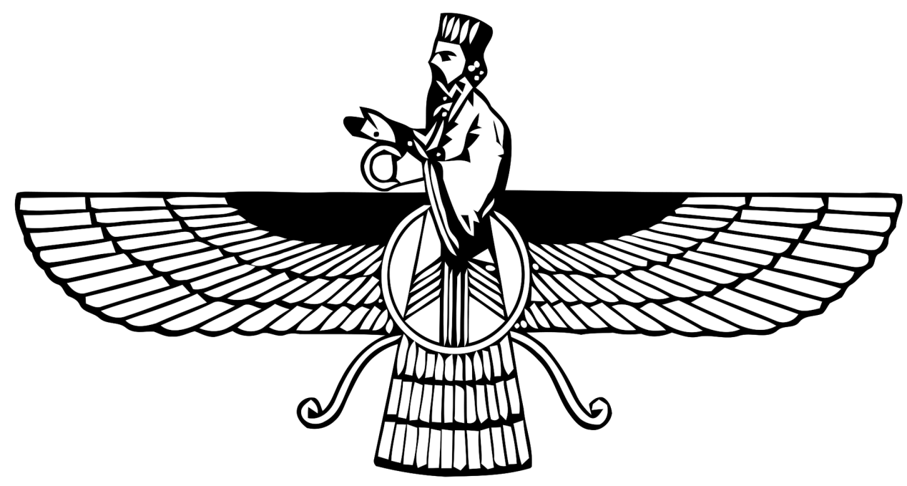In Pursuit of Aspiration – History of Different Ethnic Groups in Hong Kong and their Contribution to the Development of Hong Kong

Worksheet for site visit
Zoroastrianism in Hong Kong

Where can you see the following sign in the Zoroastrian Building? What does it stand for?
It can be seen in the lift lobby and the exterior part of the building. It is the symbol of Zoroastrianism. Everyone should have good thoughts, good deeds and good speech. Evil thoughts, evil deeds and evil speech should not be done.

1 Good thoughts

3 Good deeds
2 Good speech

6 Evil deeds
5 Evil speech

4 Evil thoughts

111

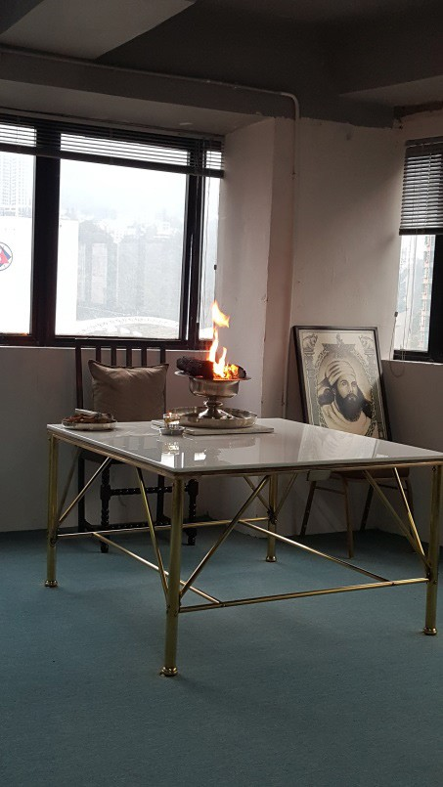In Pursuit of Aspiration – History of Different Ethnic Groups in Hong Kong and their Contribution to the Development of Hong Kong

What are inside the prayer hall?
Altar, religious picture, Zoroastrian sacred texts and tools for keeping the burning fire such as carbon and fire stand etc.
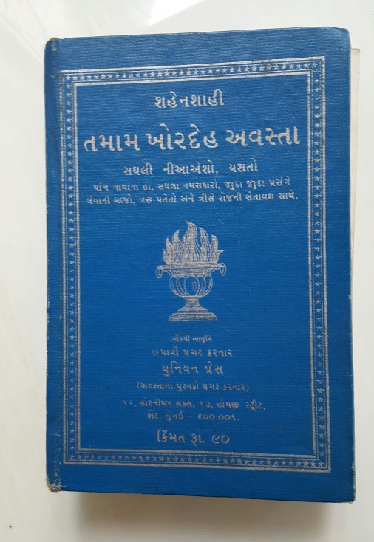

Who takes care of the burning fire? What is the religious apparel of the person-in-charge?
The Zoroastrian priest. He wears clean white clothes and puts on mask when he is handling the sacred fire.

According to your observation, what are the similarities and differences between Zoroastrianism and the other religions in Hong Kong?
Just like all the other religions in Hong Kong, the Zoroastrians have venues for religious ceremonies and gathering purposes. They will chant and follow the Zoroastrian rules and teachings. However, the Zoroastrian community is relatively small and restricted to Parsis only.

Every year on 12th October, the birthday of the late Sir H N Mody, the local Zoroastrian community commemorates his generosity of major donation to the founding of the University of Hong Kong by having their priest place a garland of flowers around the bust of Sir H N Mody. For details, please click the following link to view the webpage of University of Hong Kong:
https://www.giving.hku.hk/honouring-the-first-benefactor-of-hku-sir-h-n-mody/
u

112

In Pursuit of Aspiration
History of Different Ethnic Groups in Hong Kong and their Contribution to the Development of Hong Kong

Example 3
The Europeans (using the Germans, the Russians and the Portuguese as examples)

Personal, Social and Humanities Education Section Curriculum Development Institute, Education Bureau

Example 3
The Europeans (using the Germans, the
Russians and the Portuguese as examples)

To know more…
Learning
Objectives

Understand Europeans’ purposes of coming to Hong Kong and their lives and contributions in Hong Kong
Identify characteristics
Use collaborative skill, critical thinking skill, self-learning skill and information technology skill
Tolerate and respect other cultures
Appreciate the contributions of Europeans in Hong Kong Develop empathy and the spirit to care for the others

郭士立 | Gützlaff, K. F. A.
沙皇尼古拉二世 | Czar Nicholas II
布力架 | Braga, Jose Pedro
德國人 | the Germans
葡萄牙人 | the Portuguese
俄羅斯人 | the Russians
九龍玫瑰堂 | Rosary Church, Kowloon

Learning
^{and} Teaching
Materials

Topic 1: Getting to know different European minorities living in Hong Kong
Enquiry question 1
Why did the Europeans come to Hong Kong in the mid 19th century?

Pre-assessment: Why did they choose Hong Kong?

Enquiry question 2
What was the population and living condition of the Europeans in early Hong Kong?

Table of numbers of German, Portuguese and Russian residents in Hong Kong from 1871 to 1931 (Source A)
Leisure activities of the German, Portuguese and Russian residents in Hong Kong from 1859 to 1938 (Source B)
The Peninsula Menus, Gaddi’s (Source C) Photo of the Rosary Church (Source D)
Extended learning activity

Find some examples of schools built by the Portuguese from Caine Road to Peel Street in Central in the Internet

Topic 2:
Examine the work and contributions of the Europeans living in Hong Kong

Enquiry question 1
What were the occupations of the Europeans in early Hong Kong?

Enquiry question 2
What were the contributions of the Europeans in early Hong Kong?

Extended learning activity

Water Police Hong Kong in the 1930s (Russians) (Source A)
F. Blackhead & Co’s Soap Factory in 1908 (Germans) (Source B) Hermann Melchers, the founder of Melchers & Co. with his staff in 1873 Melchers & Co. (Germans) (Source C)
Carlowitz & Co.’s branch house in Hong Kong in 1906 (Germans) (Source D) Commercial activities of the Portuguese (Source E)

JP Braga (Portuguese) (Source F)
A newspaper article about an interview with Braga published in November 1935 (Source G)

Find out the other contributions of Europeans living in Hong Kong in the Internet

11155

Topic 1: Getting to know different European minorities living in Hong Kong

Why did the Europeans come to Hong Kong in the mid 19th century?
1

Pre-
assessment

Why did they choose Hong Kong?

Study carefully about the experience of non-English speaking Europeans in Hong Kong and circle the motive(s) they came to Hong Kong.
PrPree-- assessmenassessmentt

The Germans Economic
Most of us set up trading companies in Guangzhou from the 1840s to the 1860s and then we had our branches in Hong Kong. The
followings were some of the examples in Hong Kong : Carlowitz & Co. (1866)
Arnhold Karberg & Co. (1867) Melchers & Co. (1866)
Jebsen & Co. (1895), which is still active in the markets of Hong Kong and the mainland today.
We also came to preach in Hong Kong, e.g. Karl F. A. Gützlaff was one of our missionaries and he was also an interpreter and government official. He died in Hong Kong in 1851 and was buried in the Hong Kong Cemetery. He was described as the first Lutheran missionary to China on his tombstone.

Source: adapted and translated from 丁新豹、盧淑櫻：《非我族裔：戰前香港的外籍族群》 ( 香港：三聯書店，2014 年)
Political Religious

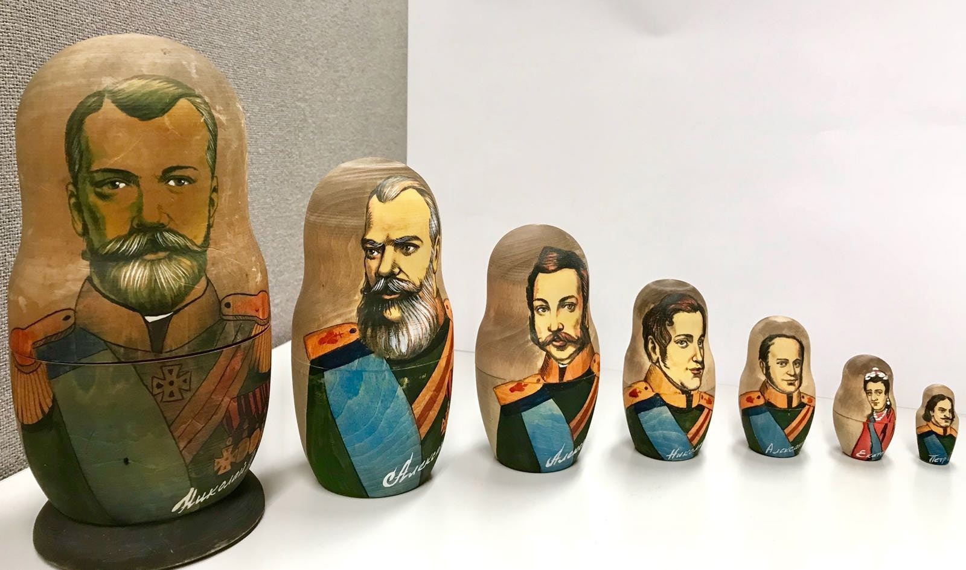

The Russians Economic
Nicholas II, our last Czar, had visited Hong Kong as a Russian prince in 1891. Hong Kong was regarded as our ideal naval base in Asia, but the British had strong defensive measures against us. Our Czar was overthrown in February 1917. Lenin set up a Communist government in the same year after the October Revolution. Soon Civil War broke out between the White Russians and the Red Russians. We were the White Russians as we were against the new Communist government. Finally the Red Russians won and we had to escape to places such as Harbin and Hong Kong to look for working opportunities. Our
Eastern Orthodox Church community came into being in the 1930s.

Source: adapted and translated from 丁新豹、盧淑櫻：《非我族裔：戰前香港的外籍族群》 ( 香港：三聯書店，2014 年), 頁 188
Political

Religious

The Portuguese Economic
Since the early 1840s, our business was getting worse in Macau. Some of our families decided to make a fortune in Hong Kong.
The unstable political situation in 1849 and the serious damages brought about by a typhoon in 1874 further triggered two
immigration movements to Hong Kong. We have famous merchant families in the 20th century. Among them, Jose Pedro Braga was an unofficial member of the Legislative Council in 1929 to 1937.
In the late 19th century, we took up a number of government posts and quite a lot of us were engaged in commerce. Most of us worked in British, American or Parsi firms and some had started their own
business. In 1861, there were 14 Portuguese firms.
We were the major donors of early cathedrals including the first
cathedral located at Wellington Street and the marble altar in the second generation of the Cathedral of the Immaculate Conception (Hong Kong) as well as the construction of the Rosary Church.

Source: adapted and translated from 丁新豹、盧淑櫻：《非我族裔：戰前香港的外籍族群》 ( 香港：三聯書店，2014 年), 頁 188
Political

Religious

What was the population and living condition of the Europeans in early Hong Kong?
2

Year | 1871 | 1876 | 1881 | 1891 | 1897 | 1901 | 1906 | 1911 | 1921 | 1931
German | 170 | 154 | 188 | 208 | 366 | 445 | 738 | 342 | 3 | 179
Portuguese | 1,367 | 1,718 | 1,869 | 2,089 | 2,267 | 1,956 | 2,310 | 2,558 | 2,609 | 3,198
Russian | 6 | 1 | 7 | 14 | 15 | 15 | 29 | 10 | 36 | 127

With reference to Source A, which country had the largest number of European residents in Hong Kong? Why? Explain your answer with reference to the information about Portuguese in Pre-assessment in this part.
Source A Table of numbers of German, Portuguese and Russian residents in Hong Kong from 1871 to 1931
Source: adapted and translated from 丁新豹、盧淑櫻：《非我族裔：戰前香港的外籍族群》( 香港：三聯書店，2014 年)
The Portuguese. Since the early 1840s, the business was getting worse in Macau. Some of the Portuguese decided to make a fortune in Hong Kong. The unstable political situation in 1849 and the serious damages brought about by a typhoon in 1874 further triggered two immigration movements to Hong Kong.

Which country had the smallest number of European residents in Hong Kong? Why? Explain your answer with reference to Source A and using your own knowledge.
The Russians. The British government was suspicious of the Russian ambition and took precautionary measures against Russia. Britain and Russia did not have close relationship despite they were allies before the First World War. It was reflected by the small number of Russian residents in Hong Kong before 1921. Those who later came to Hong Kong were mainly the White Russians who wanted to escape from the Communist regime in Russia.

With reference to Source A, describe the trends of development of the German residents in Hong Kong from 1871 to 1931. (Hints: Increasing / Decreasing)
According to Source A, the number of German residents was increasing steadily before 1906 while there was a drastic decrease before the eve of the First World War.

Which year had the fewest number of German residents in Hong Kong? Explain the reason of the changes by using your own knowledge. (Hints: consider the European situation at
that time)
There were only 3 Germans left in Hong Kong in 1921 and the number began to rise in 1931. This fluctuation should be related to the outbreak of First World War and the defeat of Germany in the War in 1918, in which Germany was the enemy of Britain.
The German properties in Hong Kong were confiscated and the German firms suffered seriously.

The Germans | The Portuguese | The Russians
Their first club house was set up in Wanchai in 1859. In 1899, they had their club house building in Kennedy Road. Inside the building, there were a restaurant, a library, a billiard room and a bowling alley etc. | Club Lusitano was set up in 1866 for the purpose of social gathering.  In 1925, Club Recreio was opened with courts for playing wooden balls, tennis, hockey and bowling greens. | No club house was set up before the Second World War. In 1938, Amateur Sporting Association was set up and it had wooden ball game with Navy Junior Team.

According to Source B, what common leisure activities did the German, Portuguese and Russian residents have in Hong Kong?
Source B Leisure activities of the German, Portuguese and Russian residents in Hong Kong from 1859 to 1938
Source: adapted and translated from 丁新豹、盧淑櫻：《非我族裔：戰前香港的外籍族群》( 香港：三聯書店，2014 年)
They enjoyed having club house as a place for social gathering and leisure activities. They liked different ball games. Even the Russians, who did not have their own club house, organised amateur sporting association and formed ball teams.

According to Sources A and B, which European ethnic group had steady and stable social life in Hong Kong?
According to Source A, the Portuguese population was increasing while Source B shows that they had their own club house in 1866 and opened Club Recreio in 1925, providing a venue for promoting constant communication and keeping their Portuguese way of social life.

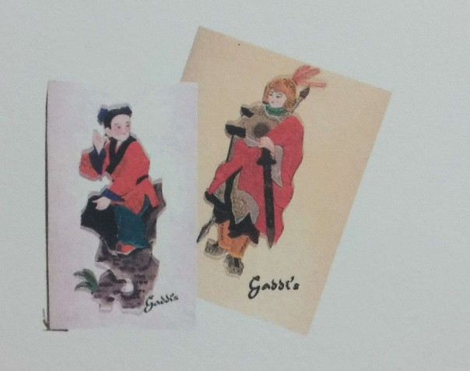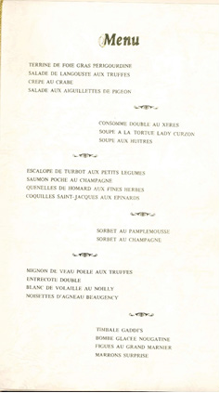Source C

The Peninsula Menu, Gaddi's

The Gaddi's in Peninsula Hotel was opened for business in 1953. As the first of Gaddi's restaurants in East Asia, it is recognized as one of the few authentic French fine-dining establishments in Hong Kong. It maintains a strict dress code to the customers.

Refer to Source 14 in Part B of this learning resource pack

- According to Source C, what is the difference between the cover design and the contents of the menu?
One of the characters who dressed in traditional Chinese costume in the menu cover was in sharp contrast with all the French foods shown in the same menu.

According to Source C, customers from which countries would come to this restaurant?
The French, the British and other Europeans who could read French would come to this deluxe French restaurant as the menu was written in French.

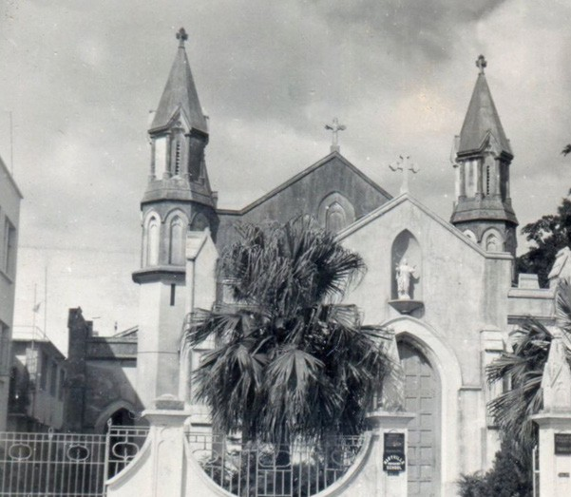Source D

Photo of the Rosary Church

Source: Hong Kong Catholic Diocesan Archives
The Rosary Church had the longest history among all the Catholic Churches in Kowloon. During the Boxer Movement, the British Government increased the garrison of Kowloon by reinforcing it from India. To meet the need of the Catholics in the Army and the nearby area, Father Giovanni M. Spada borrowed a place from the Canossian Sisters to hold a mass. Later a church that was capable to serve about 800 men was built in 1901, but it was deemed inadequate due to the large number of worshippers. Finally, a new church was decided to be built on the land granted by the Canossian Sisters, with the donations from Dr. Anthony Gomes, a Portuguese Catholic in October 1903. On 10 December 1904, Fr. De Maria laid the foundation stone of the Church. On 8 May 1905, of the work on the Rosary Church was completed, and the consecration of the Church was also held by Fr. De Maria.
Refer to Source 34 in Part B of this learning resource pack

According to Source D, what was the original site of the Rosary Church? Who sponsored the new church which was built in 1905?
The original site of the Rosary Church was a small church erected on the place borrowed from the Canossian Sisters. The new church built in 1905 was sponsored by the Canossian Sisters, which granted the land, and donations came from Dr. Anthony Gomes, a Portuguese Catholic.

Apart from the religion mentioned in Source D, what other religions came from foreign countries to Hong Kong? Give two examples.
Islam and Christianity.

In Pursuit of Aspiration – History of Different Ethnic Groups in Hong Kong and their Contribution to the Development of Hong Kong
5) What can you tell about the social life of some Europeans in Hong Kong from the 1900s to the 1950s? Explain your answer with reference to Sources C and D.
As seen from the menu in Source C, the customers of the Peninsula Hong Kong Hotel were most likely Europeans who could read French to order food. The Rosary Church in Source D originally served the Catholics in the British army only.
Extended
Learning
Activity

Extended learning activity

The Portuguese lived in the area from Caine Road to Peel Street in Central. They built schools there in the late 19th century. Find some examples of those schools in the Internet.
e.g. St. Joseph's College (its former location was in 9 Caine Road), Sacred Heart Canossian College etc.

122

Topic 2: Examine the work and contributions of the Europeans living in early Hong Kong

Source A

What were the occupations of the Europeans in early Hong Kong?

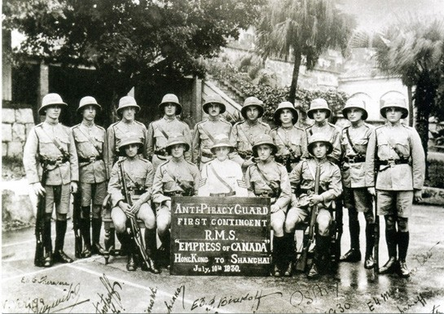Water Police Hong Kong in the 1930s (Russians)

Piracy in 19th century Southern-China was a serious problem to all authorities of the area, and it was not easily solved despite the efforts of the colonial government. In the 1920s, the piracy problem came back with a different mode. Instead of operating in pirate ships that could be hunt down by the Royal Navy or the Water Police, the pirates would infiltrate on board by dressing up like ordinary passengers, and hijack the ships when they reached the high seas. They even kidnapped rich passengers for ransoms. At that time, the Hong Kong Police recruited Russians to form an Anti-Piracy Guard, which stationed on board to deter the pirates.

Some of the Russians were veterans of the Imperial Russian Army who fought against the Bolsheviks during the Russian Civil War. Thus, they were known as “White Russians”. As many of them were forced to flee to Asia after the Civil War, some of them resided in Hong Kong.

Source: Offbeat, Issue no.777, June 16 to June 29, 2004, https://www.police.gov.hk/offbeat/777/eng/f03.htm

Refer to Source 36 in Part B of this learning pack

According to Source A, what was the occupation of the Russians living in Hong Kong in the 1930s? Why were they recruited by the Hong Kong Police to take up the posts?
Most of the Russians in Hong Kong were members of the Anti-Piracy Guard, which stationed on board to deter the pirates. They were recruited by the Hong Kong Police because some of them were veterans of the Imperial Russian Army who fought against the Bolsheviks during the Russian Civil War.

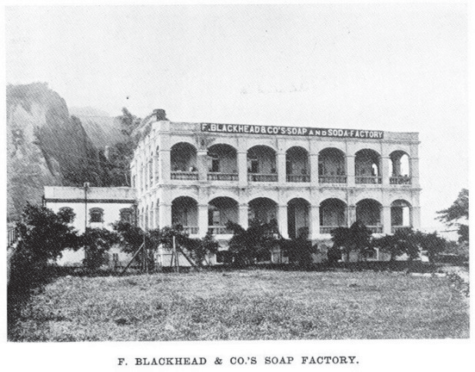
Source B F. Blackhead & Co.’s Soap Factory in 1908 (Germans)

F. Blackhead & Co. was established by a German merchant F. Schwarzkopf in Sau Kei Wan in 1890. Schwarzkopf arrived at West River of Canton in 1855 to start his business in China. He then moved to Hong Kong during the Second Opium War. His business in Hong Kong mainly focused on selling materials and coal for ships, including the German, Russian, and Austrian warships operating in Asia. Schwarzkopf’s company in Hong Kong was named after a directed translation of its original name in English, hence the name “Blackhead”. The company’s name also became the namesake of Signal Hill, which at a time was known as “Blackhead Point”. His son succeeded Schwarzkopf’s business, but the company was confiscated by the Hong Kong Government during the First World War, as Germany was an enemy of the British Empire.

Source: Walk in Hong Kong
Refer to Source 38 in Part B of this learning resource pack

According to Source B, what business did this German company run?
This was a soap factory as well as a multi-investment German company. Its business in Hong Kong mainly focused on selling materials and coal for ships,
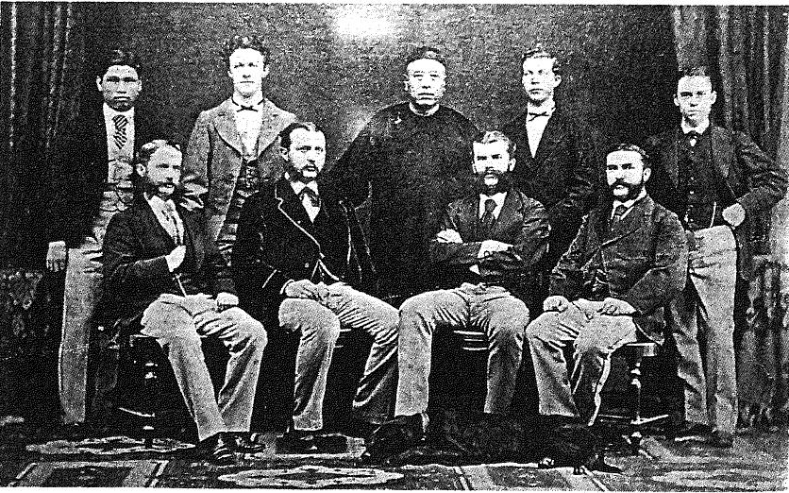
Source C Hermann Melchers, the founder of Melchers & Co. with his staff in 1873 Melchers & Co. (Germans)
Refer to Source 39 in Part B of this learning resource pack
Melchers & Co. is a large trading company with a long history. It was established by Carl Melchers and Carl Focke in 1806 in Bremen, Germany. It focused on international trade, and was the earliest European firm to start import and export business with North America. In the mid 19th century, led by Hermann Melchers, Melchers & Co. started to expand its business in East Asia. The first branch in China was established in Hong Kong in 1866. The staff picture showed that the hire of both Chinese and European staff was a common practice of foreign firms in Hong Kong at that time.

According to Source C, point out two features of the German-invested company in Hong Kong.
This is a large trading company with a long history. It was established by Carl Melchers and Carl Focke in 1806 in Bremen, Germany. Besides, the branches in Hong Kong hired a mixture of Chinese and European staff which was common in foreign firms in Hong Kong at that time.

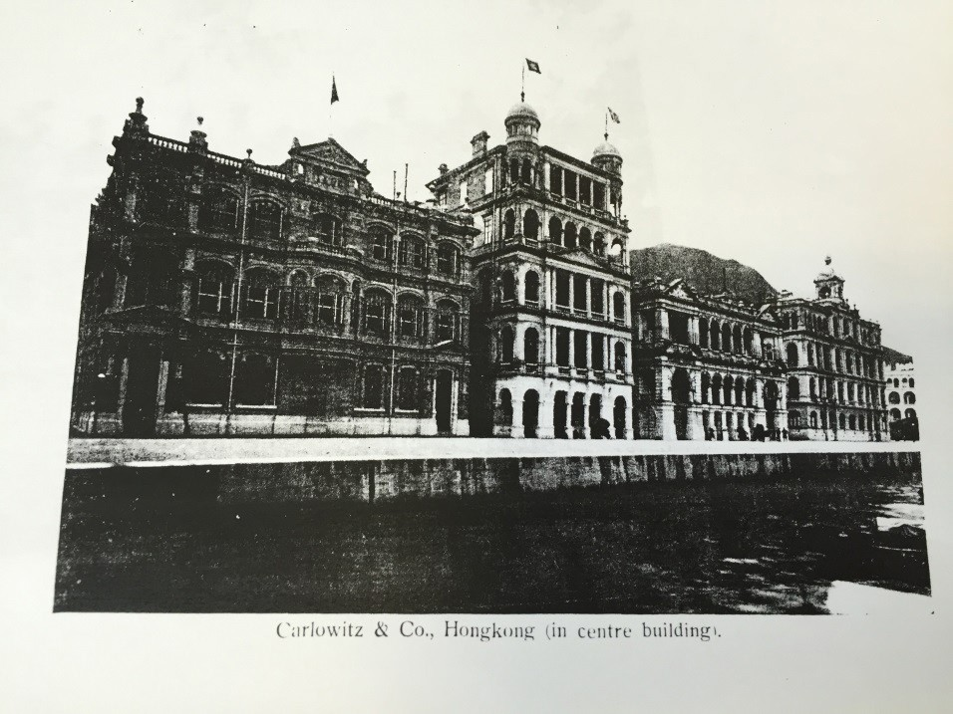
Source D Carlowitz & Co.’s branch house in Hong Kong in 1906 (Germans)

Carlowitz & Co. was one of the most influential German firms in East Asia. It was founded by Richard von Carlowitz, the first Consul of the Kingdom of Prussia and Kingdom of Saxony in Canton, and German merchant Bernhard Harkort. In 1855, Carlowitz took over the company after Harkort returned to Germany. A decade later, he established a branch office in Hong Kong. Carlowitz & Co. was famous for importing German- made heavy machinery, mining equipment, and weapons to Asia. It was also the agent in China for Krupp and Bofors, both major producers of arms at that time. At the time this photo was taken, the headquarters of Carlowitz & Co. was already relocated to Shanghai.

Refer to Source 40 in Part B of this learning resource pack.

According to Sources C and D, compare the similarities and differences between the two German-invested companies in Hong Kong.
Both companies had a long history and they set up branches in Hong Kong in 1866. However, they ran different businesses. Melchers & Co. was a trading company which focused on international trade while Carlowitz & Co. imported mainly German-made heavy machinery, mining equipment and weapons.

Number of people engaged in commerce
1849 | 35 persons serving in 22 trading companies.
1861 | 113 persons serving in 46 trading companies. | 14 trading companies opened by the Portuguese.
Famous trading companies
1844 | Noronha & Co. | I t w a s t h e f i rst p r i n t i n g company in Hong Kong. I t p r i n t e d t he H ong K ong G o v er n m en t G a z e t t e a n d of f i c ial printed document s s i n c e 1 8 5 9 a n d w a s t h e former Government Logistics Department.
1857 | Rozario & Co. | It was engaged in exporting d a i l y n e c e s s i t i e s t o S a n Francisco and Honolulu.
1904 | Cruz, Basto & Co. | It was engaged in importing f lour and dair y foods f rom Australia as well as silk and santalum album business.

According to Source E, what were the occupations of the Portuguese in Hong Kong?
Source E Commercial activities of the Portuguese
Source: adapted and translated from 丁新豹、盧淑櫻：《非我族裔：戰前香港的外籍族群》( 香港：三聯書店，2014 年)
From Source E, quite a number of Portuguese were engaged in trading business, either serving in trading companies or having their own business.

What were the contributions of the Europeans in early Hong Kong?
2

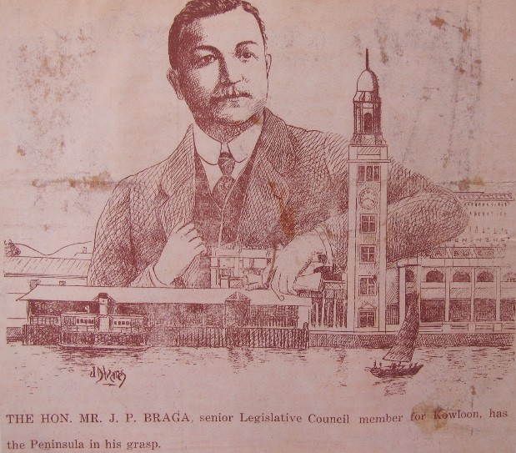Source F
JP Braga (Portuguese)

The HON. MR. J.P. Braga Senior Legislative Council member for Kowloon has the Peninsula in his grasp.
Jose Pedro Braga (1871-1944) was an important politician and businessman in Hong Kong before Second World War. He was graduated from St. Joseph College and worked for the Hongkong Telegraph and Reuters as a reporter. Later in 1919 he was commissioned as a Non-Official Justice of the Peace. He was then appointed to the Sanitary Board, the Legislative Council, Playing Fields Committee, and also the Committee of Broadcasting. Braga was very active in the business circle, serving in leading firms including the Hong Kong, Canton and Macau Steamboat Co., Ltd, Hong Kong Rope Manufacturing Co., Ltd. He also cultivated a close relationship with influential Chinese and European businessmen like Robert Hotung. When the Japanese invaded Hong Kong in 1941, he moved to Macau, but passed away there in 1944. Braga Circuit at Mongkok was named after him.

Refer to Source 33 in Part B of this learning pack

According to Source F, J. P. Braga was an important politician and businessman in Hong
Kong before Second World War. Identify one example about politics and business respectively to illustrate your answer.
In politics: He was a senior Legislative Council member for Kowloon
In business: He served in leading firms including the Hong Kong, Canton and Macau Steamboat Co., Ltd.

Source G The following is adapted from a newspaper article, which was published in November 1935. It was about Braga’s response in an interview about an agricultural association set up by him in the New Territories.
In view of the improving quality of agricultural goods and the fast-growing development of agricultural industry, the association accomplished its mission. Despite living in Tsim Sha Tsui, far away from the New Territories, I would visit there at least once a week. I may visit there alone, or with my friends. The Agricultural Show has been launched for years up to now. When the Agricultural Show commenced in 1932, the Canadian trade commissioner provided us with seeds of Canadian potatoes. One year later, thanks to the seeds, the show offered Canadian potatoes of outstanding quality for exhibition, which was of the same quality as those imported ones. The major agricultural goods of the New Territories in which consumed locally are vegetables. Papaya and jackfruit are also welcomed by the market. Not only can jackfruit be consumed freshly, it can also be canned for exportation, while papaya is also favored by westerners. Some orchards in which thousands of orange trees and lychee trees are built in Tai Po. Besides, chicken and pig farmers are also common in Tai Po. Being able to produce more eggs, which means more income, the white haired chicken from Britain was especially favored by farmers. Based on the above-mentioned situation, one might expect that the farmers would have a reasonable life. It was, however, a misconception. Being poor, most of the farmers are seriously indebted. Having paid off their debt at the end of the year, the farmers might even have difficulties in supporting their lives.
Source: Translated from 香港工商日報 , November 1935

Based on Sources F and G, design a poster, which shows Braga’s contributions to Hong Kong. (The following answers are for reference only.)
The poster design should include examples of Braga's contributions to Hong Kong in both
Sources F and G.
- According to Sources A to G, complete the following table about the contributions of the Europeans in Hong Kong.

Source | evidence / example | Significance
Source A | Hong Kong Police employed some Russian residents for the Anti-Piracy Guard | Acted as an important Navy force to protect the shipping from piracy.
Source B | German owned Soap Factory in Hong Kong | Provided job opportunities for Hong Kong people.
Source C | The first branch of the Melchers & Co in China was established in Hong Kong in 1866. | Provided job opportunities for Hong Kong people and expanded Hong Kong’s trading business to East Asia.
Source D | Carlowitz & Co. , German- capital Corporation in East Asia. | Expanded Hong Kong’s trading business to East Asia
Source E | Noronha & Co. owned by the Portuguese | The first publishing company in Hong Kong
Source F | Jose Pedro Braga was an important politician and merchant in Hong Kong. | A member of the Sanitary Board and the Legislative Council and had served in leading firms such as the Hong Kong, Canton and Macau Steamboat Co. Ltd. and the Hong Kong Rope Manufacturing Co., Ltd.
Source G | Braga, a Portuguese, established an agricultural association in the New Territories. | Improved quality of both agriculture and farming products.

In Pursuit of Aspiration – History of Different Ethnic Groups in Hong Kong and their Contribution to the Development of Hong Kong
Extended
Learning
Activity

Extended learning activity

Find out the other contributions of European residents which are not mentioned in the above sources in the Internet.

(The following answers are for reference only.)

The contributions of other Europeans:
  - Brought commercial development to Hong Kong, such as establishing banks, building piers and godown, developing shipping businesses, etc.
  - Provided social welfare, such as founding schools and churches, giving necessities to the needy, etc.

129

In Pursuit of Aspiration
History of Different Ethnic Groups in Hong Kong and their Contribution to the Development of Hong Kong

Example 4
The Indians, the Sikhs and the Filipinos

Personal, Social and Humanities Education Section Curriculum Development Institute, Education Bureau

Example 4
The Indians, the Sikhs and the Filipinos

To know more…
To know more : Chinese-English Glossary
Learning
Objectives

Understand how the different ethnic groups of different periods make a living in Hong Kong as well as their
history and culture
Identify the usefulness and limitations of historical sources Use critical thinking skill, self-learning skill and information technology skill
Care for others
Appreciate the cultures of different ethnic groups
Tolerate and care for the others, and Cherish all around in the presence

印度人 | the Indians
錫克人 | the Sikhs
菲律賓人 | the Filipinos
錫克教 | Sikhism
中區警署（大館） | Central Police Station (Tai Kwun)

In Pursuit of Aspiration – History of Different Ethnic Groups in Hong Kong and their Contribution to the Development of Hong Kong

Learning
^{and} Teaching
Materials

Topic :
How did the different ethnic groups of different periods make a living in Hong Kong?

Enquiry question 1
What occupations had the Indians and the Sikhs engaged in early Hong Kong?

Police Report published in The Hongkong Government Gazette, 1870 (Source A)
A photo taken in 1885 showing Officers of the Police Force (Source B) Indian and Chinese police officers in 1900 (Source C)
CLP Staff Record (HKHP) (Source D)

Extended learning activity 1

Where can we find the footprints of the Sikh policemen in early Hong Kong?

Enquiry question 2
What occupations had the Filipinos engaged in early Hong Kong?

The following description is about the Filipino song Kowloon Hong Kong
(Source E)
The following description is about the Filipino song Anak (Source F) Documentation series, The Filipina Maids in Hong Kong (Source G)
The number of Filipinos, Thais, and Indonesians in Hong Kong, 1979-2011 (Source H)

Extended learning activity 2

What were the events and people related to Filipino music in Hong Kong from the Second World War to the 1970s?

132
132

In Pursuit of Aspiration – History of Different Ethnic Groups in Hong Kong and their Contribution to the Development of Hong Kong

Topic : How did the ethnic minority groups of different periods make a living in Hong Kong?

What occupations had the Indians and the Sikhs engaged in early Hong Kong?
1

I. Sources A to D help us understand about some occupations of the Indians and the Sikhs in early Hong Kong.

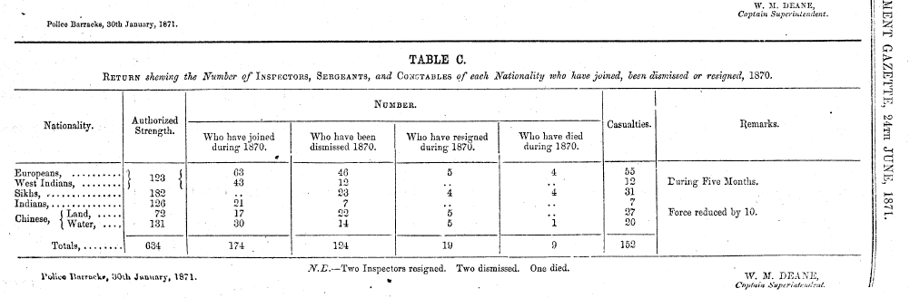Source A

Police Report published in The Hongkong Government Gazette, 1870 (Indians, Sikhs and West Indians)

Chief Magistrate William Caine established the Hong Kong Police in 1844. With European staff in the beginning, Chinese joined the Police force next year. In the 1860s, the Police force started to recruit Indians. In the 1870s, there were 634 Chinese, European and Indian police, including 123 came from Europe and West India, 182 Sikhs, 126 Indians and 203 Chinese (131 of them are Marine Police).

Note:
Europeans – members from Europe
West Indians — members from British West Indies, which consist of the Bahamas, Barbados, British Guyana, Honduras, Jamaica, Trinidad and Tobago.
Sikhs — the Sikhs, mainly from Punjab province in the north-western India Indians — Indians from other areas of British India
Chinese – Land — Chinese Policemen Chinese – Water — Chinese Marine Policemen
Refer to Source 21 in Part B of this learning resource pack

133

In Pursuit of Aspiration – History of Different Ethnic Groups in Hong Kong and their Contribution to the Development of Hong Kong

With reference to Source A, describe the characteristics of the formation of Hong Kong police force in 1870.
There were 308 Sikhs (182) and Indians (126), almost half of the police force. 203 Chinese was just one- third of the total and they were mostly the Marine police (131 out of 203). Europeans and West Indians were the minorities with just one-fifth of the total police force.

With reference to Source A, what was the role of different ethnic groups in the Hong Kong Police Force at that time?
They helped to maintain public order and the Sikhs together with the Indians formed the majority in police force.

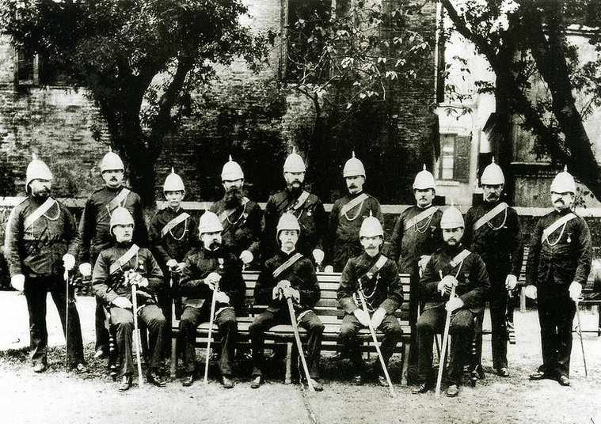
Source B
A photo taken in around 1885 showing Officers of the Police Force. At centre amid the seated was Captain Superintendent of the Police, Walter Meredith Deane.

Source : Solomon Bard, Voices from the Past: Hong Kong 1842-1918, Hong Kong University Press, 2002.

According to Source B, which ethnic groups had occupied the ranks of police officers in early Hong Kong?
The British or the Europeans

134

In Pursuit of Aspiration – History of Different Ethnic Groups in Hong Kong and their Contribution to the Development of Hong Kong

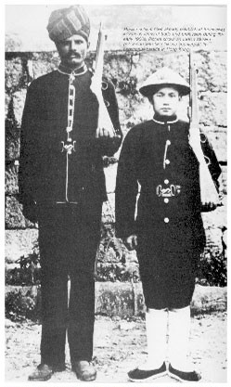Source C

Indian and Chinese police officers in 1900

Source: Walk in Hong Kong

In the 1900s, many Indians were recruited by the Hong Kong Police, some of them were veterans came from British Indian Army, and the uniform for Indian policemen was quite similar to the European Army uniform style. As the Indian was nicknamed "Moro"（摩羅）by the Chinese in Hong Kong, the Indian policemen were also called "Morocha"（摩羅差）. Under the localization policy, the ratio of Chinese among the Police force also increased gradually. The Chinese policemen also had a uniform in different style compare with their Indian colleagues. They wore a green tunic, a Chinese style bamboo hat and a pair of cloth shoes.

Refer to Source 22 in Part B of this learning resource pack.

- With reference to Source C, analyse the different advantages of Indian police and the Chinese police in maintaining public order.
The Indian police were stronger and taller which was an advantage in carrying out their duties whereas the Chinese police were in a better position for communication with local people as well as understanding Chinese culture.

With reference to Source C, what were the differences in outlook between the Sikh and Chinese policemen?
The Sikh policeman dressed in European style uniform since some of them had been serving in the British Indian Army. He wore turban which is the symbol of Sikhism. In contrast, the Chinese policeman wore a Chinese style bamboo hat and a pair of cloth shoes .

135

In Pursuit of Aspiration – History of Different Ethnic Groups in Hong Kong and their Contribution to the Development of Hong Kong

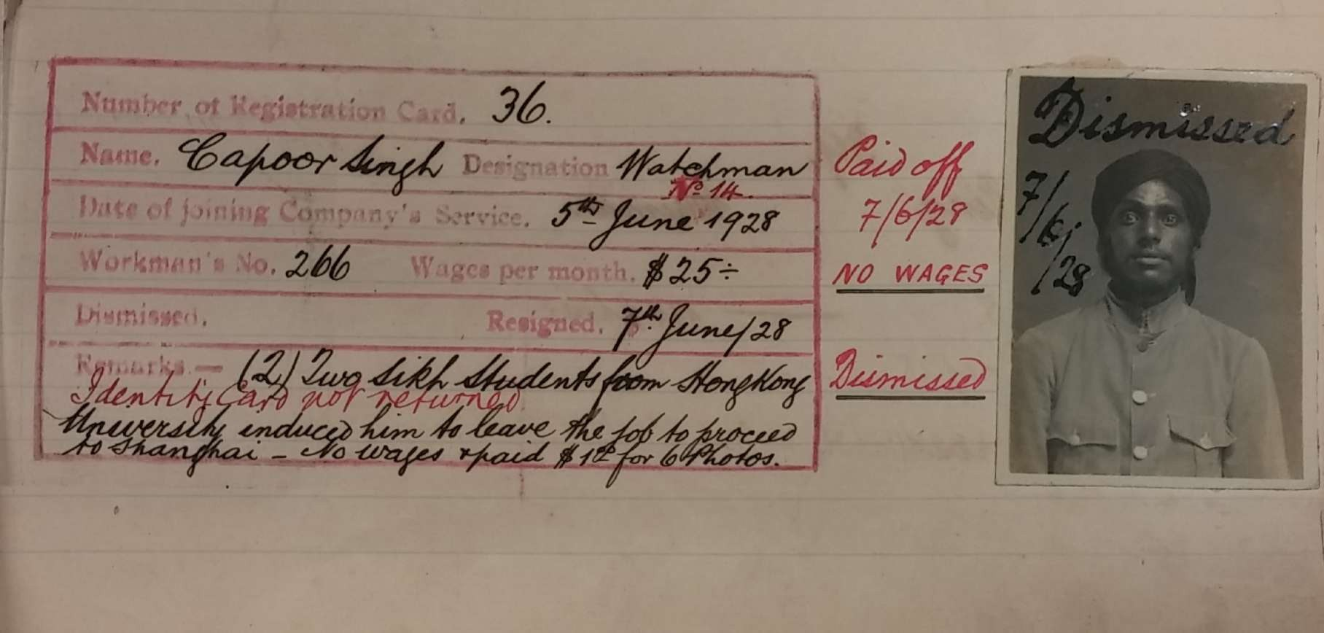
Source D
CLP Staff Record (Indian)

Source: The Hong Kong Heritage Project
The photo above was a Staff Record of China Light & Power Company (CLP) in the late 1920s. The CLP was established in 1901 as one of the two electricity suppliers in Hong Kong. The staff record shows that he started his appointment as a watchman on 5th June, 1928 with a monthly salary $25. Interestingly, the remarks on the record show that the staff resigned just only two days after he took office, as two Sikh students urged him to go to Shanghai. Therefore, he could not receive any wages and needed to pay for the fee of six photos. His identity card was also dismissed and not returned.

Refer to Source 20 in Part B of this learning resource pack.

With reference to Source D, why did the man resign suddenly?
It was written in the remarks that his Sikh students induced him to leave for Shanghai. The man resigned suddenly was probably because of this reason.

According to Sources A, C and D, how did some Indians and Sikhs make a living in Hong Kong?
They were largely engaged in jobs related to security and keeping law and order in society.

136

In Pursuit of Aspiration – History of Different Ethnic Groups in Hong Kong and their Contribution to the Development of Hong Kong
Extended
Learning
Activity

Extended learning activity (1)

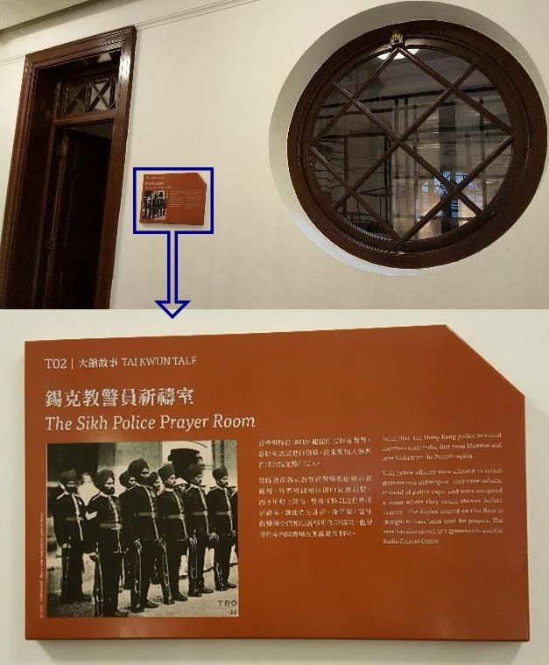(*can be used as teachers' reference or provide to students for self-directed learning)

Where can we find the footprints of the Sikh policemen in early Hong Kong?
The “Tai Kwun Tales” of Tai Kwun in Central introduces the Sikh Police Prayer Room to the public. Though it has been renovated to become a display room of early Chinese style café for visitors, the old photo and its explanation outside this room provide good references to understand the history of the Sikh policemen in the old days.

From 1861, the Hong Kong police recruited members from India, first from Mumbai (Bombay) and later Sikhs from the Punjab region.

Sikh police officers were allowed to retain their customs and religion – they wore turbans instead of police caps, and were assigned a room where they could shower before prayers. The duplex located on this floor is thought to have been used for prayers. The area had also served as a gymnasium and the Radio Control Centre.

137

In Pursuit of Aspiration – History of Different Ethnic Groups in Hong Kong and their Contribution to the Development of Hong Kong
2

What occupations had the Filipinos engaged in early Hong Kong?

III. Sources E to H are about the Filipinos living in Hong Kong.
Source E The following description is about the Filipino song Kowloon Hong Kong.
English was the official language in Hong Kong from 1843 to 1974. It was spoken widely in social gatherings and formal context in the 20th century. English pop songs were popular. In the pre-WWII period, many bandleaders and musicians were Filipinos. Among them were Lobing Samson, Fred Carpio and Vic Cristobal etc. For example, The Reynettes (1960) had a very popular song Kowloon Hong Kong with easy English and highlights of Hong Kong as a global city. The Hong Kong Tourism Board even used the song to promote the city.
Source: adapted from the following website
https://en.wikipedia.org/wiki/Hong_Kong_English_pop

According to Source E, why was the Filipino song Kowloon Hong Kong so popular in Hong Kong?
It has a catchy sound of a simple melody and its repetitious lyrics reflect the features of Hong Kong.

Source F The following description is about the Filipino song Anak .
"Anak" is a song written by Filipino singer Freddie Aguilar. It was a finalist for inaugural 1977 Metropop Song Festival held in Manila. It became an international hit and was translated into many different languages. The lyrics was about parental love. The Chinese version of this song, with lyrics composed by Cheng Kwok Kong and sung by Alan Tam, was released in 1979. Since the 1950s, many Filipino musicians who stayed in Hong Kong played Western music in nightclubs and contributed in the music industry of Hong Kong. “Anak” can be seen as an example of Filipino influence on Hong Kong as well as the result of improvements in information technology and the prevalence of popular culture.

Refer to Source 43 in Part B of this learning resource pack

According to Source F, why was the Filipino song Anak so popular in Hong Kong?
Because the lyrics are about parental love, the Chinese version was composed and sung by famous songwriter and artist in Hong Kong. Anak can earn resonance in Hong Kong.

According to Sources E and F, what occupation did the Filipinos have in Hong Kong before and after the Second World War? Why?
In the pre-WWII period, some Filipinos in Hong Kong were engaged in music industry. They formed popular bands and wrote songs. Since English was already the official language in Hong Kong in the 1950s, it was spoken widely in social gatherings and formal context in the 20th century. Thus, there was a stable market for English songs. (Source E)
In the 1950s, a group of Filipino musicians played Western music in nightclubs of Hong Kong. (Source F)

138

In Pursuit of Aspiration – History of Different Ethnic Groups in Hong Kong and their Contribution to the Development of Hong Kong
Extended
Learning
Activity

Extended learning activity (2)
What were the events and people related to Filipino music in Hong Kong from the Second World War to the 1970s?

(*can be used as teachers' reference or provide to students for self-directed learning)
You may search the relevant information from the following websites:
1) 〈大上海飯店廣告〉，《華僑日報》，1942 年 5 月1 日
https://books.google.com.hk/books?id=20CrCgAAQBAJ&pg=PA105&lpg=PA105&dq=%E8%8F
%B2%E5%BE%8B%E8%B3%93%E9%9F%B3%E6%A8%82%E7%89%B9%E8%89%B2&source=
bl&ots=B8pGO9_AEa&sig=lwYeyL888rRQIzIYDMNYLqhU0M0&hl=zh-TW&sa=X&ved=0ahUKE widybGhuObZAhUfT48KHQNsAjA4ChDoAQhUMAs#v=onepage&q=%E8%8F%B2%E5%BE%8B
%E8%B3%93%E9%9F%B3%E6%A8%82%E7%89%B9%E8%89%B2&f=false
2)
黃湛森：〈菲律賓音樂人– 技藝〉，《粵語流行曲的發展與興衰：香港流行音樂研究》，香港：香港大學，2003 年。
頁 47-49)
http://www.hkmemory.org/jameswong/wjs/web/upload/book/8077phdthesis_p47-49.pdf

139

In Pursuit of Aspiration – History of Different Ethnic Groups in Hong Kong and their Contribution to the Development of Hong Kong

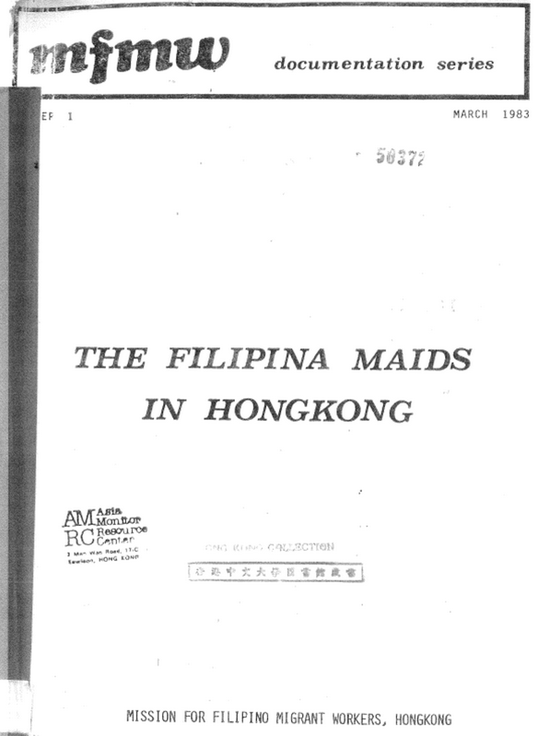Source G

Documentation series, The Filipina Maids in Hong Kong (Filipino)

Source: Mission for Filipino Migrant Workers, Hong Kong

The Mission for Migrant Workers (MFMW) Ltd. is a registered charitable organisation. Established in 1981, the MFMW is an outreach program of the St. John's Cathedral of Hong Kong Anglican Church. It provided services in the aspects of religion, social welfare and education for Filipino domestic workers in Hong Kong. One of the purposes of this document was to show why there was an increasing number of Filipino maids in Hong Kong. Before the 1970s, the number of Filipino maids was only a few hundred but it grew rapidly after 1982 to over 19,000 by the end of that year. In the 1980s, Hong Kong needed female labour force to participate in service and manufacturing industries. The government purposely encouraged the input of foreign domestic helpers. Since then, the Filipinos have gradually become part of the Hong Kong society and contributed to the development of Hong Kong.

Refer to Source 44 in Part B of this learning resource pack

140

In Pursuit of Aspiration – History of Different Ethnic Groups in Hong Kong and their Contribution to the Development of Hong Kong

Source H

The number of Filipinos, Thais, and Indonesians in Hong Kong, 1979-2011

 | 1979 | 1981 | 1983 | 1985 | 1987 | 2001 | 2006 | 2011
The  Philippines | 9,500 | 15,100 | 24,200 | 32,200 | 39,100 | 142,556 | 112,453 | 133,018
Thailand | 6,200 | 8,600 | 9,200 | 9,600 | 10,100 | 14,342 | 11,900 | 11,213
Indonesia | 2,700 | 3,500 | 3,700 | 3,900 | 3,300 | 50,494 | 87,840 | 133,377

Reference: Hong Kong 1980, Hong Kong 1982, Hong Kong 1984, Hong Kong 1986, Hong Kong 1988 and 2011 Hong Kong Population Census
After the Second World War, many Southeast Asian countries became independent, such as the Philippines and Indonesia. Some of the nationals migrated and settled in Hong Kong. Thailand was the only independent country in Asia during the age of colonialism; the Thai people also settled in many Asian cities, including Hong Kong, forming numerous unique communities. As Hong Kong experienced a period of rapid economic growth after the war, many Southeast Asian people chose to live in the city. From the above chart, one can see that there were around 18,400 people from the Philippines, Thailand, and Indonesia living in Hong Kong. The figure rose to 280,000 in 2011. The increase was largely due to the influx of domestic helpers from the Philippines and Indonesia.

Refer to Source 42 in Part B of this learning resource pack.

With reference to Source G, why did Hong Kong start to employ foreign workers as domestic helpers?
Hong Kong was in the age of industrialization in the 1970s. Many local females joined the labour market so the government decided to open the gate for the Filipino to work as domestic helpers in Hong Kong.

With reference to Sources G and H, describe the trend of population and explain the key factor for the change.
From the chart above, there were 18,400 residents combining the Filipinos, Thais and Indonesians. This figure rose to 280,000 in 2011 representing a huge growth in number. The key factor was the scale of hiring foreign people as domestic workers in Hong Kong, mainly from the Philippines and Indonesia.

141

In Pursuit of Aspiration
History of Different Ethnic Groups in Hong Kong and their Contribution to the Development of Hong Kong

Extended Learning
Mody, Chater, Nathan, Kadoorie Family and the Kowloon Peninsula

Personal, Social and Humanities Education Section Curriculum Development Institute, Education Bureau

Extended
Learning
Mody, Chater, Nathan, Kadoorie Family and the Kowloon Peninsula

To know more…

Learning
Objectives
Develop their responsibility to inherit history, and preserve the cultural heritage.

Relate the study of the past to contemporary life
Appreciate the contributions of different ethnic groups in Hong Kong Learn the spirit of pioneering, innovation and entrepreneurship through the contributions of different ethnic groups on Hong Kong
Analyse change and continuity
Use critical thinking skill and information technology skill
Understand the contributions of the different ethnic groups living in early Hong Kong in the making of the Kowloon Peninsula

 | 麼地爵士 | Sir Mody, H. N.
 | 遮打爵士 | Sir Chater, Catchick Paul
 | 彌敦爵士 | Sir Nathan, Matthew
 | 嘉道理家族 | Kadoorie Family
 | 九龍半島 | Kowloon Peninsula
 | 亞美尼亞 | Armenia

In Pursuit of Aspiration – History of Different Ethnic Groups in Hong Kong and their Contribution to the Development of Hong Kong

Learning
^{and} Teaching
Materials

Topic :
Mody, Chater, Nathan, Kadoorie Family and the Kowloon Peninsula

Enquiry question
In what ways did the ethnic minorities take part in the development of Kowloon Peninsula?

Streets in Kowloon Peninsula and the Ethnic Minorities (Worksheet 1) Kowloon Peninsula at the turn of the Century (Worksheet 2)
Hong Kong map sketched after the signature of Beijing Convention, 1860 (Source A)
Map of Kowloon Peninsula in 1907 (Source B)
Mody, Chater, Nathan, Kadoorie Family and the Kowloon Peninsula (Worksheet 3)
Appendix
Extended learning activity
How much do you know about the origin of the street names on the Kowloon Peninsula?

144
144

In Pursuit of Aspiration – History of Different Ethnic Groups in Hong Kong and their Contribution to the Development of Hong Kong

In what ways did the different ethnic groups take part in the development of Kowloon Peninsula?

Worksheet 1
Streets and Buildings in Kowloon Peninsula and the Different Ethnic Groups

On the Kowloon Peninsula, there are numerous streets and buildings that are related to different ethnic groups. Can you name some examples of them?
Please sketch a mind map to indicate those streets and buildings in question.

Streets that are related to different ethnic groups

Suggested answers:
Streets: Braga Circuit, Kadoorie Avenue, Nathan Road and Mody Road etc.

Streets and buildings that are related to different ethnic groups

Buildings: The Kowloon Mosque, Kowloon Cricket Club and China Light and Power’s Headquarter etc.

Buildings that are related to different ethnic groups

145

In Pursuit of Aspiration – History of Different Ethnic Groups in Hong Kong and their Contribution to the Development of Hong Kong

Worksheet 2
Kowloon Peninsula at the turn of the Century

Read Sources A and B to compare the transformation before and after 1900.

Source A

Hong Kong map sketched after the signature of Beijing Convention, 1860

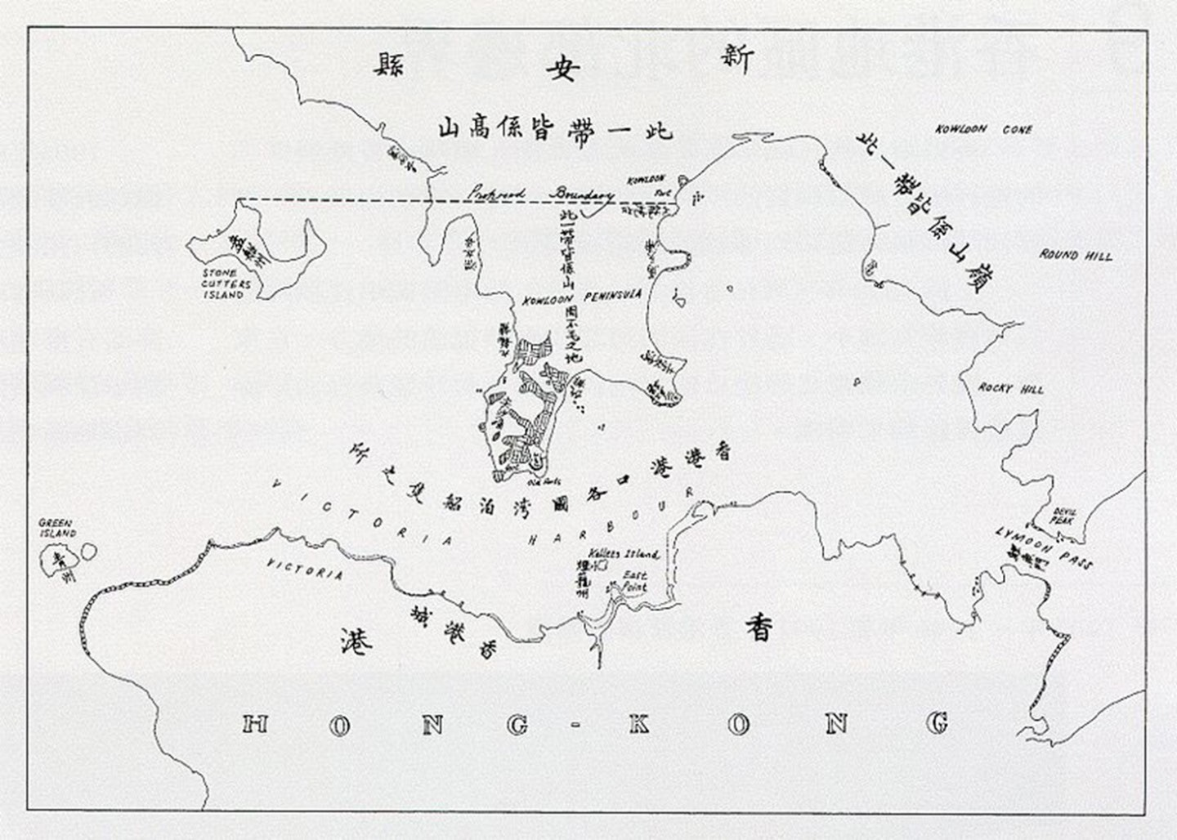

Source : https://commons.m.wikimedia.org/wiki/File:Map_of_Hong_Kong_in_First_Convention_ of_Peking_in_1860.jpg

146

In Pursuit of Aspiration – History of Different Ethnic Groups in Hong Kong and their Contribution to the Development of Hong Kong

Source B

Map of Kowloon Peninsula in 1907

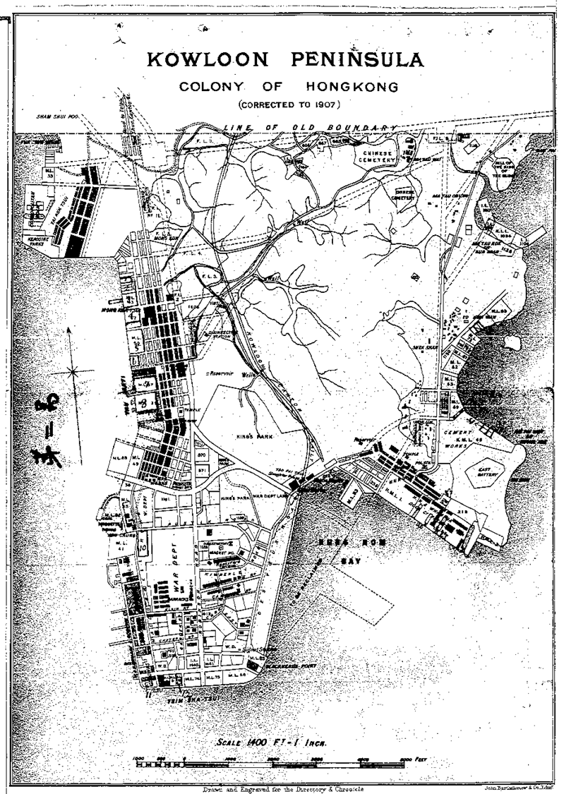

Source : Japan Centre for Asian Historical Records
https://www.jacar.go.jp/english/

With reference to Sources A and B, identify the changes that had taken place on the Kowloon Peninsula in the period 1860-1907.
There was large scale land reclamation along the western, southern and south-eastern parts of the Kowloon Peninsula as shown by the long and straight coastline in Source B. As a result, Kowloon Peninsula changed from a barren place to a small planned city with a basic road network and initial city infrastructure along the coastal area.

Following question 1, name the current locations where major changes had taken place.
Tsim Sha Tsui, Hung Hom, Yau Ma Tei and Tai Kok Tsui

147

In Pursuit of Aspiration – History of Different Ethnic Groups in Hong Kong and their Contribution to the Development of Hong Kong

Worksheet 3

Mody, Chater, Nathan, Kadoorie Family and the Kowloon Peninsula

Mody, Chater, Nathan and Kadoorie Family played key roles in the course of the urbanisation of the Kowloon Peninsula. Please refer to the sources in Part B and search for relevant
information from the interent and library, and complete the table below about their contributions to the development of Hong Kong.

Name | Ethnicity | Contribution to the development of the Kowloon Peninsula
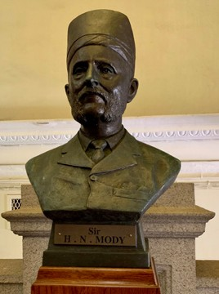  Mody | Parsi | - invested heavily in the landed properties around Tsim Sha Tsui;  - contributed to the reclamation at the south-western tip of the Kowloon Peninsula;  - founded the Kowloon Wharf & Godown, a base for maritime trade.
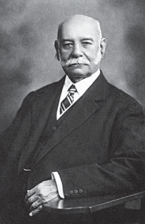  Chater | Armenian
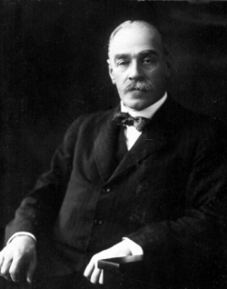  Nathan | Jew | - reorganised and extended the motorway network on the Kowloon Peninsula.  - devoted to develop the southern end of the Kowloon Peninsula with a target to make it a transport hub connected by maritime transport, motorways and railways;  - initiated the construction of the Kowloon-Canton Railway;  - established wireless communication station for meteorological precautions.
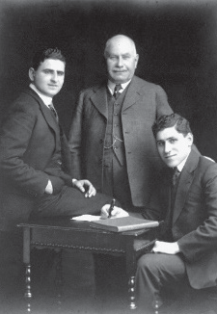  The Kadoories | Jew | - established China and Light Power Company Limited, the power supplier for the Kowloon Peninsula;  - had a heavy investment in the Hong Kong Hotel Company Limited and constructed the Peninsula Hotel which enjoyed a worldwide reputation.

148

In Pursuit of Aspiration – History of Different Ethnic Groups in Hong Kong and their Contribution to the Development of Hong Kong
Extended
Learning
Activity

Extended learning activity : How much do you know about the origin of the streets on the Kowloon Peninsula?

Suggested answers

- Which streets on the Kowloon Peninsula are related to the ethnic minorities in Hong Kong?
Braga Circuit, Kadoorie Avenue, Nathan Road and Mody Road etc.

- Why were those streets named after them?
It was because they had different contributions to the development of the Kowloon Peninsula. For example, Braga was an important politician and businessman before the Second World War and he had actively participated in the development of Kowloon; Kadoorie Family had core businesses such as the China Light & Power Company (CLP) and the Peninsula Hotel and established the Kadoorie Agricultural Aid Association; Nathan had been the Hong Kong Governor and was devoted to develop the Kowloon Peninsula and managed to extend its motorway network while Mody invested heavily in property development in Tsim Sha Tsui.

149

In Pursuit of Aspiration

History of Different Ethnic Groups in Hong Kong and their Contribution to the Development of Hong Kong

Site visit
Religious buildings of different ethnic groups in Hong Kong

Personal, Social and Humanities Education Section Curriculum Development Institute, Education Bureau

Site visit Religious buildings of different ethnic groups in Hong Kong

Learning
Objectives

Understand the religion and relevant buildings of different ethnic groups and features of the routes for site visits

Care about history and culture
Appreciate and respect the religious culture of different ethnic groups
Trace the historical development and analyse the cause-and-effect relationship
Use collaborative skill, critical thinking skill, self-learning skill and information technology skill

In Pursuit of Aspiration – History of Different Ethnic Groups in Hong Kong and their Contribution to the Development of Hong Kong

Learning
^{and} Teaching

Materials

Schedule for site visit

Pre-trip preparation
What I know about different ethnic groups in Hong Kong

Brief rundown
Frayer Model (Worksheet 1)
Briefly introduce the major occupation of different ethnic groups in early Hong Kong (Appendix 1)

Different ethnic groups in Hong Kong – Who’s Who and their occupation (Worksheet 2)
Introduction to the religions of the different ethnic groups and their religious buildings (Appendix 2)
Different ethnic groups in Hong Kong – their religions (Worksheet 3)

Different ethnic groups and their religious buildings in Hong Kong

Points to note for site visits

Site visits

Sum up session
Suggested route 1 for Central and Mid-levels:
(Students are advised to study information of each checkpoint before the trip, and complete Worksheet 4 with their observations in the trip.)
Maps for route 1 and route 2 Suggested route 2 for Causeway Bay:
(Students are advised to study information of each checkpoint before the trip, and complete Worksheet 5 with their observations in the trip.)

Observing cultural diversity in Hong Kong from different ethnic groups and their religious cultures

Conclusion for Site Visit

152
152

In Pursuit of Aspiration – History of Different Ethnic Groups in Hong Kong and their Contribution to the Development of Hong Kong

Bridf Introduction of plan

Since the early 19th century, numerous foreign businessmen came to China as the trade flourished. From 1842 onwards, a considerable number of them settled in Hong Kong and different ethnic groups have thus taken shape. By visiting their religious buildings, students will be offered an opportunity to appreciate the tolerance of and respect for other cultures in Hong Kong.

This plan includes 1 lesson for pre-trip preparation, 1-2 lessons for students’ presentation and conclusion about their field visits. In addition, there are two suggested routes for the site visit.

- Pre-trip preparation: Different ethnic groups’ contribution to Hong Kong in its early decades and their religious culture (35 minutes)

- Site visit: Different religions and cultures in Hong Kong (3-4 hours)

- Concluding session: Religious buildings and the cultural diversity of Hong Kong (35-70 minutes)

The plan also has some QR codes attached which link to relevant websites of the respective body that the religious architecture belongs to, Antiquities and Monuments Office or Lord Wilson Heritage Trust, so as to deepen students’ understanding of the religious architecture related to the route of the site visit.

153

Different ethnic groups’ contribution to early Hong Kong and their religious cultures

Targeted group: Junior Form students Duration: 35 minutes
Relevant topic: The Growth and Development of Hong Kong up to the late 19th
century / The Growth and Transformation of Hong Kong in the 20th century

Objectives:
Before the lesson, students should have:
  - basic knowledge about the history of early Hong Kong up to the end of the late 19th century;
  - basic knowledge on the social structure in the early days of Hong Kong up to the end of the late 19th century.

At the end of the lesson, students should be able to understand:

- the main occupations and the contribution of the different ethnic groups who arrived Hong Kong in its early days up to the end of the late 19th century;
- the various religious cultures that the different ethnic groups introduced to Hong Kong and the subsequent formation of cultural diversity.

154

Duration 10 mins

10 mins
Content
To encourage the students to think about what they know about different ethnic groups in Hong Kong (in particular their places of origin, features, occupations and languages) (Worksheet 1)

To briefly introduce the major occupations of different ethnic groups in early Hong Kong (see Appendix 1)
- Government Officials
- Politician and businessman
- Disciplinary Forces
- Merchants
- Labour and Seamen
To help students jot down the lives of people representing different ethnic groups and their contribution to Hong Kong (Worksheet 2)

15 mins
To introduce religious buildings in Hong Kong by using the different ethnic groups’ religious faiths as an entry point (see Appendix 2)
- Christianity – The Hong Kong Catholic Cathedral of The Immaculate Conception, St. Margaret’s Church (Catholic); The Church of Christ in China Hop Yi Church, SKH St. Mary’s Church, SKH St. John’s Cathedral
- Islam – Jamia Mosque, Masjid Ammar and Osman Ramju Sadick Islamic Centre, Kowloon Mosque and Islamic Centre
- Judaism – Ohel Leah Synagogue
- Zoroastrianism – Zoroastrian Building
- Sikhism - Khalsa Diwan Sikh Temple
- Hinduism – Hindu Temple of Hong Kong

To guide the students to summarise their basic knowledge about various religious faiths (Worksheet 3)

155

In Pursuit of Aspiration – History of Different Ethnic Groups in Hong Kong and their Contribution to the Development of Hong Kong

Worksheet 1
What I know about different ethnic groups in Hong Kong

Do you know what different ethnic groups are there in Hong Kong? Where are they from? Draw pictures and/ or write in the table below to show how much you know about them.

Where do they come from? For example:
India
Pakistan Nepal
the Philippines Indonesia
Thailand
What religions do they have? For example:
Believes in Hinduism, Islam,
Catholicism or other religions.

Different ethnic groups in Hong Kong

Work in different jobs, for example:

Reporters, Native-speaking English teachers, Engineers, Security guards, Couriers,
Domestic helpers, etc
For example:

Hindi, Urdu, Nepali, Filipino, Indonesian, Thai, etc

What are their occupations? What are their languages?

156

In Pursuit of Aspiration – History of Different Ethnic Groups in Hong Kong and their Contribution to the Development of Hong Kong

Worksheet 2
Different ethnic groups in Hong Kong – Who’s Who and their occupation

Different ethnic groups have had contributions to Hong Kong’s development. Write down your own observation about their lives and achievements.

- Which categories did their occupations belong to? Please write your answers in the left column.

- Among all historical figures and sources, which one is the most familiar to you? Why?

Officials in early Hong Kong | 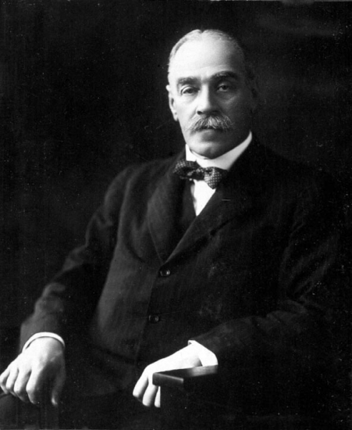  Refer to Source 6 of Part B in this learning resource pack | Sir Matthew Nathan
 |  | Jew (British Nationality)
 |  | Hong Kong Governor (1904-1907)
Politician and Businessman | 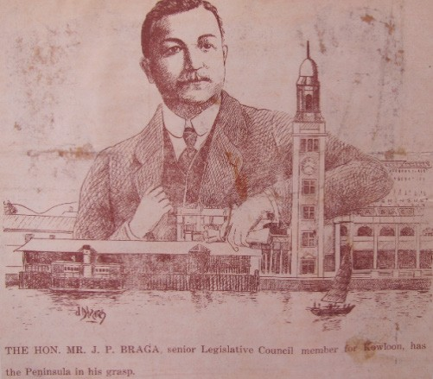  Refer to Source 33 of Part B in this learning resource pack | J.P. Braga
 |  | Portuguese
Members of the Sanitary Board, the
Legislative Council, the Playing Fields’ Committee, the Broadcast Committee and the Consultative Committee of the Hong Kong Volunteer Defence Force

157

In Pursuit of Aspiration – History of Different Ethnic Groups in Hong Kong and their Contribution to the Development of Hong Kong

Disciplinary Forces | Refer to Source 36 of Part B in this learning resource pack | Russian
 |  | Hong Kong Police Force
 |  | Anti-pirate operations
Businessmen | 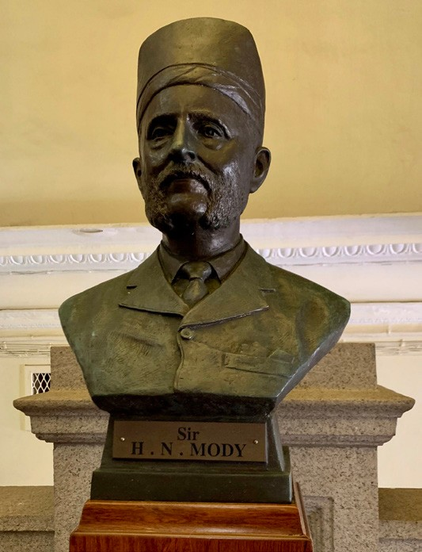  Refer to Source 29 of Part B in this learning resource pack | Hormusjee Naorojee Mody
 |  | Parsi
Banking, Auctioneering, Stock
Exchange, Gold Bullion Market and Property Market
 |  | Donation to The University of Hong Kong
 | 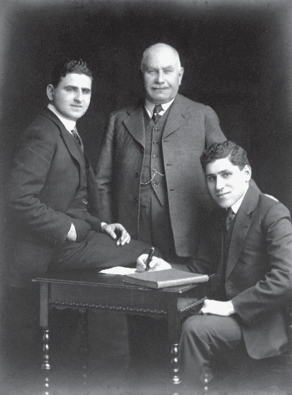  Refer to Source 8 of Part B in this learning resource pack | The Kadoorie Family
 |  | Jews
 |  | Owned the electric power company and hotels

158

In Pursuit of Aspiration – History of Different Ethnic Groups in Hong Kong and their Contribution to the Development of Hong Kong

Worksheet 3

Different ethnic groups in Hong Kong – their religions

Each ethnic group in Hong Kong has its own religion and religious buildings. Do you have any idea about their religious buildings? Please fill in the form below with suitable answers.

Different Ethnic Groups in Hong Kong | Religions | Denominations | Buildings
British | Christianity | Anglican Church | SKH St. John’s Cathedral  SKH St. Mary’s Church
Portuguese Irish |  | Protestant Church | The Church of Christ in China Hop Yat Church
 |  | Roman Catholic Church | The Hong Kong Catholic Cathedral of the Immaculate Conception  St. Margaret’s Church
Muslims from South Asia and the Middle East | Islam | Jamia Mosque (Jamia Masjid) Masjid Ammar and  Osman Ramju Sadick Islamic Centre The Kowloon Mosque
Jews from the Middle East | Judaism | The Ohel Leah Synagogue
Parsi | Zoroastrianism | Zoroastrian Building
Indian | Sikhism | The Sikh Temple
Indian | Hinduism | The Hindu Temple

159

Different ethnic groups and their religious buildings in Hong Kong

Target group: Junior secondary students
Duration: about 3-4 hours for all checkpoints and 2 hours for any 3 checkpoints

Checkpoints: 6 in total

Suggestions:

Related topics:
Select any 3 checkpoints for pre-trip preparation and the other 3 for site visits to facilitate comparison.
Hong Kong’s Development and Growth up to the late 19th century
/ The Growth and Transformation of Hong Kong in the 20th century

Objectives:
Before the site visit, students should have basic knowledge of
- the lives and cultures of different ethnic groups (Refer to the relevant primary sources in Part B of this learning resource pack);
- the names of religious buildings of different ethnic groups;
- the routes and locations of different sites for field visits (Refer to the maps in the Site Visit).
By the end of the visit, students are expected to understand
- the features of religious buildings of different ethnic groups;
- the interaction between religious buildings and the community.

Notes for arranging site visits:
- These trips are designed for achieving a better understanding of Hong Kong’s cultural diversity through the visits to different religious buildings;
- Inter-subject collaboration, subjected to the availability of school resources, is recommended for a broader perspective for the trip.
- Please take note that the total distance of the trips is considerably long. Teachers may make suitable adjustment.
- Please pay attention to the traffic in the area of visits, which is on most occasions busy.
- There is no parking space for large vehicles in Route 1. The best available option is public transport.
- Please note that some religious buildings are not open to the public.
- Guided tours are available in a number of destinations. Please make pre-arrangement with the relevant bodies.
160

Source: Google maps

Route 1 – Central to Mid-levels Route
Students are advised to study information related to each checkpoint, and complete Worksheet 4 with their observations in the trip.

Checkpoint A
Lascar Rows, Sheung Wan Address: Lower Lascar Row, Sheung Wan.

Upper Station Street
Lok Ku Road
Tai Ping Shan Street

Kui In Fong

Caine Road

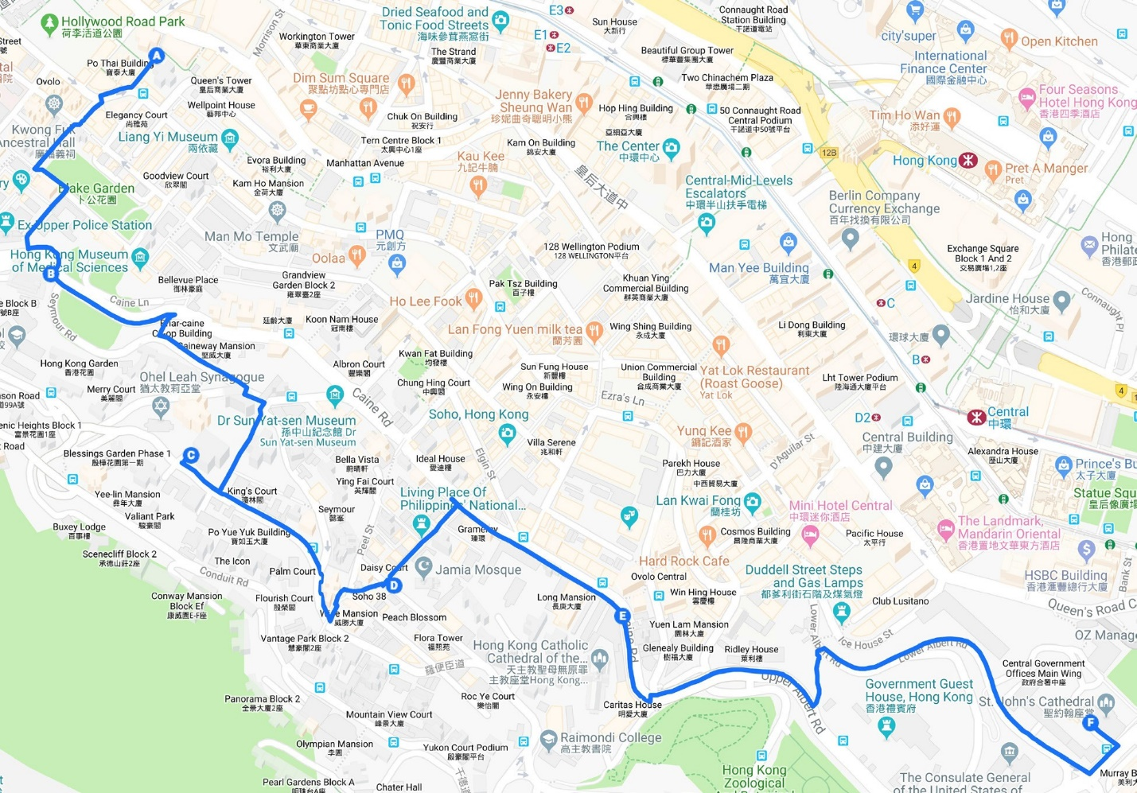
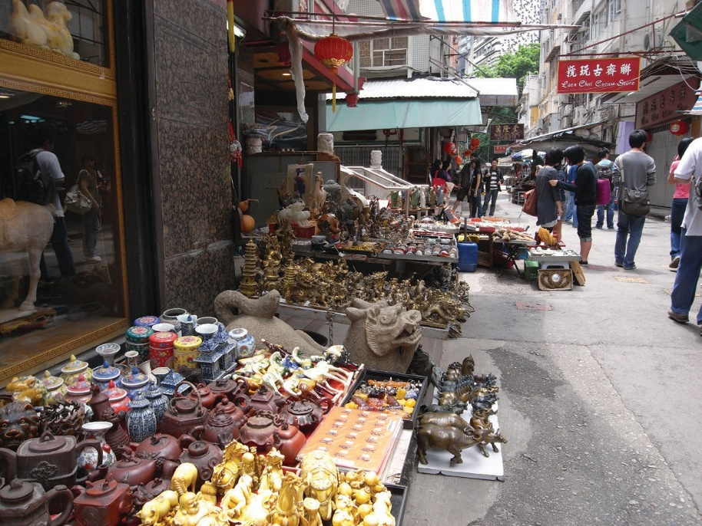

161

Checkpoint B

The Church of Christ in China Hop Yat Church
Address: No. 2 Bonham Road

Scan the QR code for further details (Chinese version only)

Caine Road

Checkpoint C
Seymour Road
Castle Road
Robinson Road

The Ohel Leah Synagogue Address: 70 Robinson Road, Mid- levels

Scan the QR code for further details

Robinson Road

Checkpoint D

Peel Street

Mosque Junction

Shelley Street

Jamia Mosque (Jamia Masjid or Shelley Street Mosque) Address: 30 Shelley Street, Central, Hong Kong.

Scan the QR code for further details

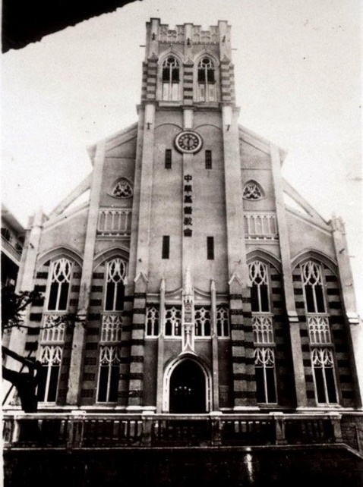
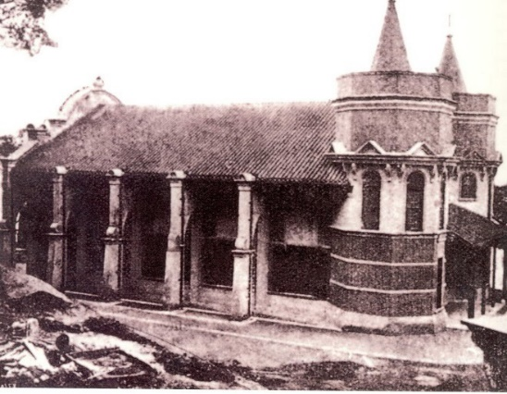
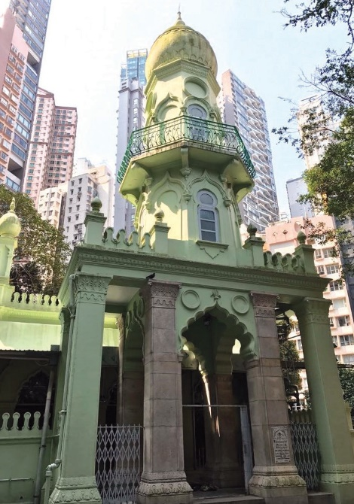
Shelley Street
Caine Road
Glenealy

162
St. Joseph Terrace

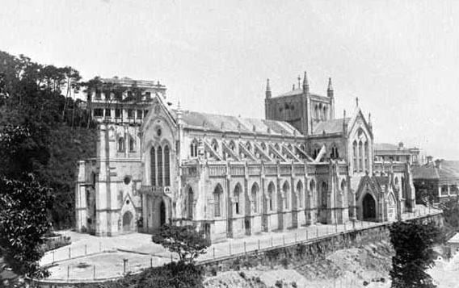
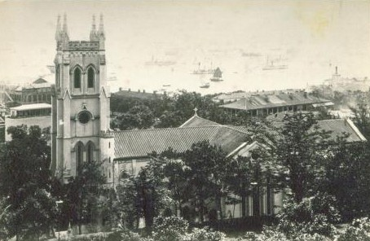

Checkpoint E

The Hong Kong Catholic
Cathedral of the Immaculate Conception
Address: 16 Caine Road

Scan the QR code for further details (Chinese version only)

Glenealy Upper Albert Road
Garden Road

Checkpoint F

SKH St. John's Cathedral
Address: 4-8 Garden Road, Central, Hong Kong.

Scan the QR code for further details

The QR codes above link to relevant websites of the respective body that the religious architecture belongs to, Antiquities and Monuments Office or Lord Wilson Heritage Trust, so as to deepen students’ understanding of the religious architecture related to the route of the site visit.

163

In Pursuit of Aspiration – History of Different Ethnic Groups in Hong Kong and their Contribution to the Development of Hong Kong

Worksheet 4
Religion, religious buildings and cultural diversity (Central-Mid-levels Route)
During the visit to these sites and religious religious buildings, understand the stories of different ethnic groups living in early Hong Kong up to the end of the late 19th century. Complete the worksheet based on your observations and put photos in the spaces below for comparison.

 | Photo in the past | Photo today | Focus questions
Lascar Rows, Sheung Wan |  |  | ˙Indicate the religion that the building belongs to.  ˙Indicate the ethnic group that introduced this religion to Hong Kong.  ˙Indicate the architectural feature(s) of the religious building by using text or drawing.  ˙Indicate the features of the environment  / community near the religious building.  ˙How similar do you think the religious building is to its original appearance after completion?  Extremely similar to the original appearance  1  2  3  4  5  6  7  8  9  10  Extremely different from the original appearance
 | Photo of an Indian
 | policeman (commonly
 | known as “Moors” ) and a
 | Chinese policeman
The Church of Christ in China Hop Yat Church | 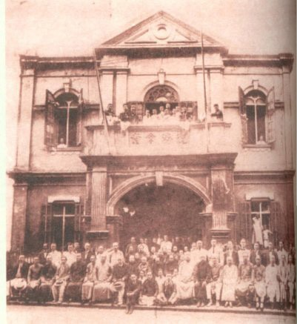
 | Founded in 1888

164

In Pursuit of Aspiration – History of Different Ethnic Groups in Hong Kong and their Contribution to the Development of Hong Kong

 | Photo in the past | Photo today | Focus questions
The Ohel Leah Synagogue | 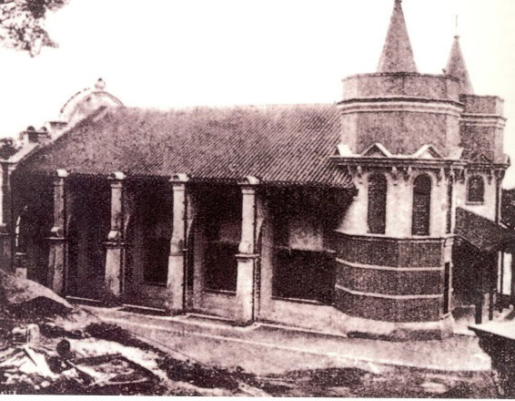  Founded in 1902 |  | ˙Indicate the religion that the building belongs to.  ˙Indicate the ethnic group that introduced this religion to Hong Kong.  ˙Indicate the architectural feature(s) of the religious building by using text or drawing.  ˙Indicate the features of the environment  / community near the religious building.  ˙How similar do you think the religious building is to its original appearance after completion?  Extremely similar to the original appearance  1  2  3  4  5  6  7  8  9  10  Extremely different from the original appearance
Jamia Mosque (Jamia Masjid) | 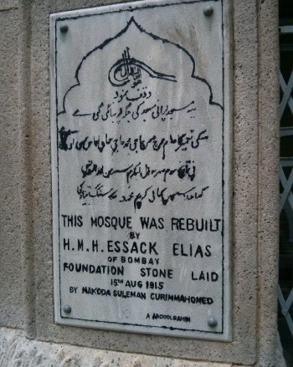  Extension project done in 1915
The Hong Kong Catholic Cathedral of the Immaculate Conception | 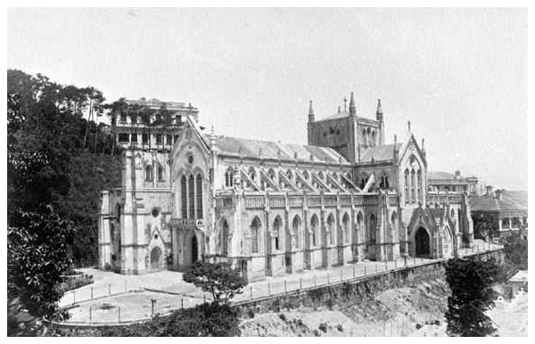  1897

165

In Pursuit of Aspiration – History of Different Ethnic Groups in Hong Kong and their Contribution to the Development of Hong Kong

 | Photo in the past | Photo today | Focus questions
SKH St. John’s Cathedral | 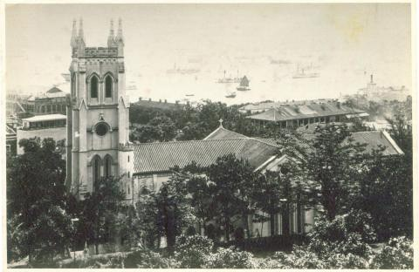  1897 |  | ˙Indicate the religion that the building belongs to.  ˙Indicate the ethnic group that introduced this religion to Hong Kong.  ˙Indicate the architectural feature(s) of the religious building by using text or drawing.  ˙Indicate the features of the environment  / community near the religious building.  ˙How similar do you think the religious building is to its original appearance after completion?  Extremely similar to the original appearance  1  2  3  4  5  6  7  8  9  10  Extremely different from the original appearance

With reference to your observations during the visit, do you think there is cultural diversity in Hong Kong? Illustrate your answer with an example you have seen during the visit.

166

In Pursuit of Aspiration – History of Different Ethnic Groups in Hong Kong and their Contribution to the Development of Hong Kong

Route 2 – Causeway Bay Route
Students are advised to study information related to each checkpoint,
Source: Google maps
and complete Worksheet 5 based on their observations in the trip.

Checkpoint A
HKSKH St. Mary’s Church Address: No. 2A Tai Hang Road, Causeway Bay

Scan the QR code for further details (Chinese version only)

Causeway Bay Road
Leighton Road

Checkpoint B
Zoroastrian Building Address: 101 Leighton Road, Causeway Bay

Scan the QR code for further details

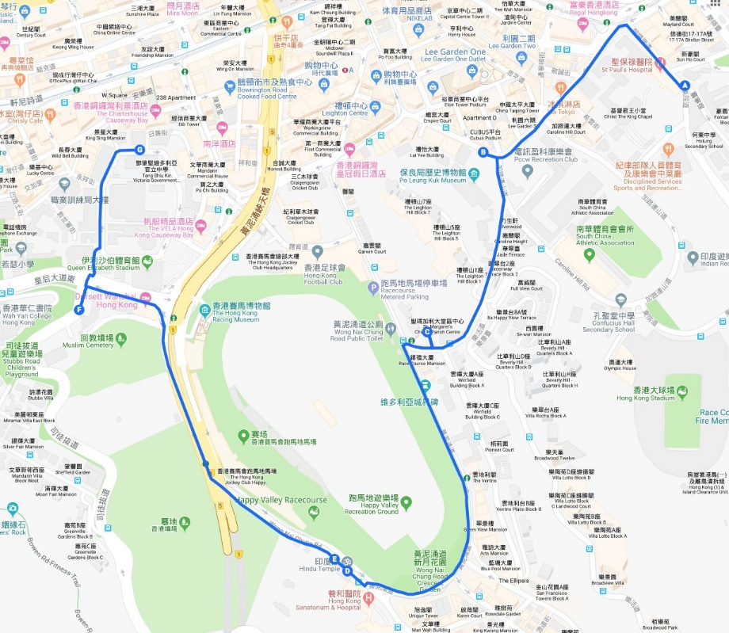
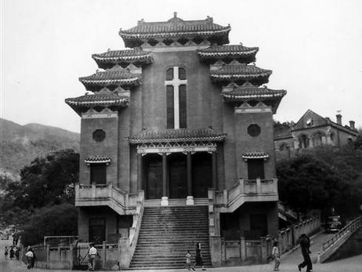
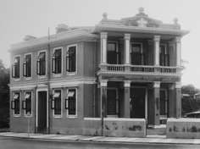
Leighton Road
Wong Nai Chong Road

167

In Pursuit of Aspiration – History of Different Ethnic Groups in Hong Kong and their Contribution to the Development of Hong Kong

Checkpoint C
St. Margaret’s Church Address: 2A Broadwood Road, Happy Valley

Scan the QR code for further details

Wong Nai Chong Road

Checkpoint D

Hindu Temple
Address: NO. 1B Wong Nai Chong Road, Hong Kong

Scan the QR code for further details

Wong Nai Chong Road

Checkpoint E

Parsee Cemetery
Address: Wong Nai Chong Road, Happy Valley, Hong Kong

Scan the QR code for further details

Wong Nai Chong Road
Queen’s Road East

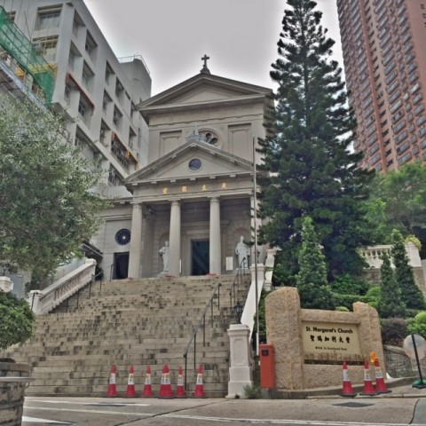
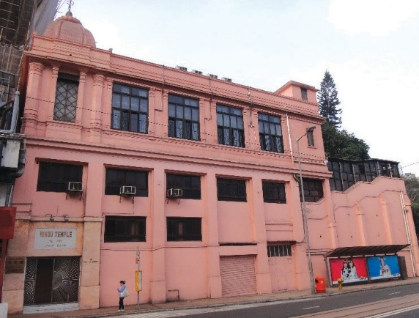
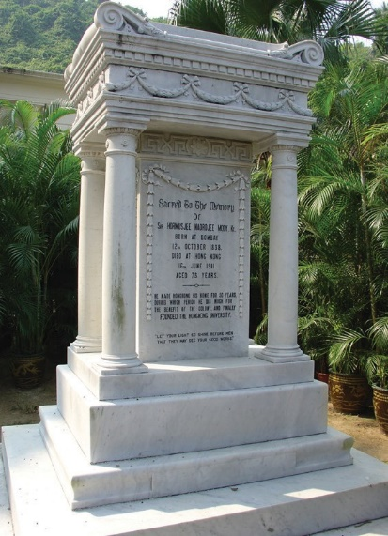
168

In Pursuit of Aspiration – History of Different Ethnic Groups in Hong Kong and their Contribution to the Development of Hong Kong

Checkpoint F

Sikh Temple
Address: No. 371 Queen’s Road East, Wan Chai

Scan the QR code for further details

Queen’s Road East

Checkpoint G

Oi Kwan Road

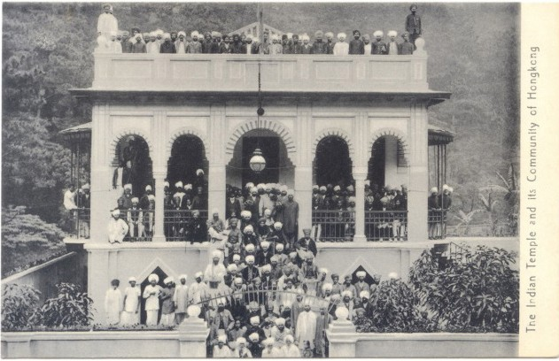
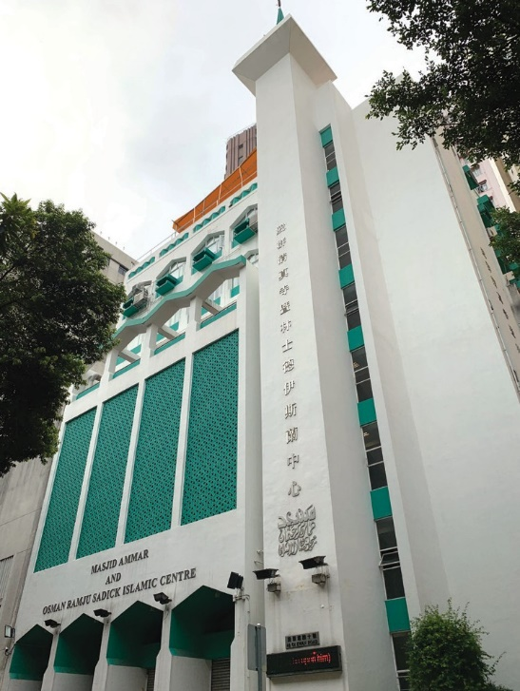

Masjid Ammar and Osman
Ramju Sadick Islamic Centre
Address: 40 Oi Kwan Road, Wan Chai

Scan the QR code for further details

The QR codes above link to relevant websites of the respective body that the religious architecture belongs to, Antiquities and Monuments Office or Lord Wilson Heritage Trust, so as to deepen students’ understanding of the religious architecture related to the route of the site visit.

169

In Pursuit of Aspiration – History of Different Ethnic Groups in Hong Kong and their Contribution to the Development of Hong Kong

Worksheet 5
Religious faiths, religious buildings and cultural diversity (Causeway Bay Route)
During the visit to these religious buildings, understand the stories of different ethnic groups living in early Hong Kong up to the end of the late 19th century. Complete the worksheet and put photos in the spaces below for comparison.

 | Photo in the past | Photo today | Focus questions
SKH St. Mary’s Church | 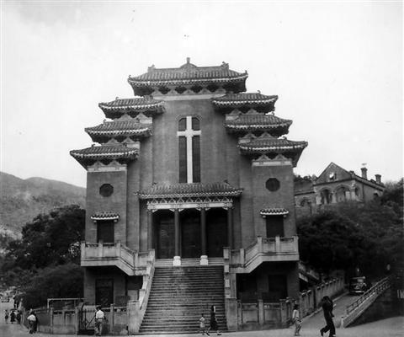  St. Mary’s Church in 1952 |  | ˙Indicate the religion that the building belongs to.  ˙Indicate the ethnic group that introduced this religion to Hong Kong.  ˙Indicate the architectural feature(s) of the religious building by using text or drawing.  ˙Indicate the features of the environment  / community near the religious building.  ˙How similar do you think the religious building is to its original appearance after completion?  Extremely similar to the original appearance  1  2  3  4  5  6  7  8  9  10  Extremely different from the original appearance
Zoroastrian Building | The early photo of the Zoroastrian Building
St. Margaret’s Church | 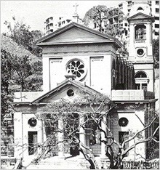  St. Margaret’s Church in the1950s

170

In Pursuit of Aspiration – History of Different Ethnic Groups in Hong Kong and their Contribution to the Development of Hong Kong

The Hindu Temple |  | 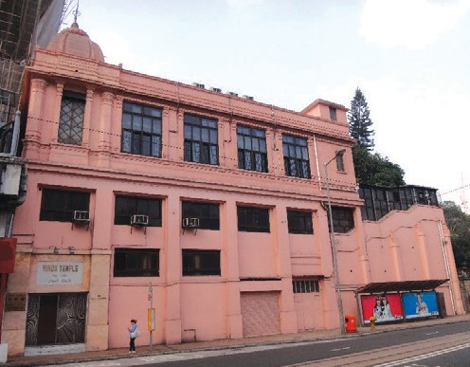  The Hindu Temple today | ˙Indicate the religion that the building belongs to.  ˙Indicate the ethnic group that introduced this religion to Hong Kong.  ˙Indicate the architectural feature(s) of the religious building by using text or drawing.  ˙Indicate the features of the environment  / community near the religious building.  ˙How similar do you think the religious building is to its original appearance after completion?  Extremely similar to the original appearance  1  2  3  4  5  6  7  8  9  10  Extremely different from the original appearance
Parsi Cemetery | 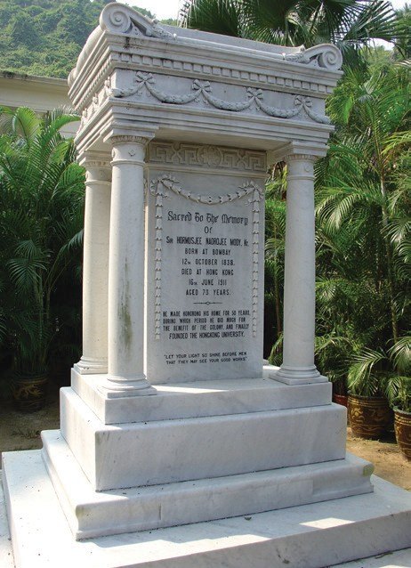  The grave of Sir H. N. Mody in the Parsi Cemetery
Sikh Temple | 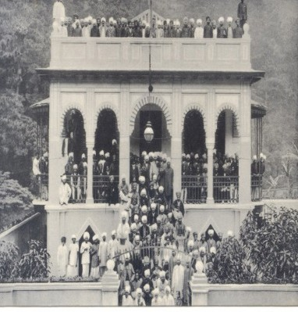  Sikh Temple in its early days

171

In Pursuit of Aspiration – History of Different Ethnic Groups in Hong Kong and their Contribution to the Development of Hong Kong

Masjid Ammar and Osman Ramju Sadick Islamic Centre |  | 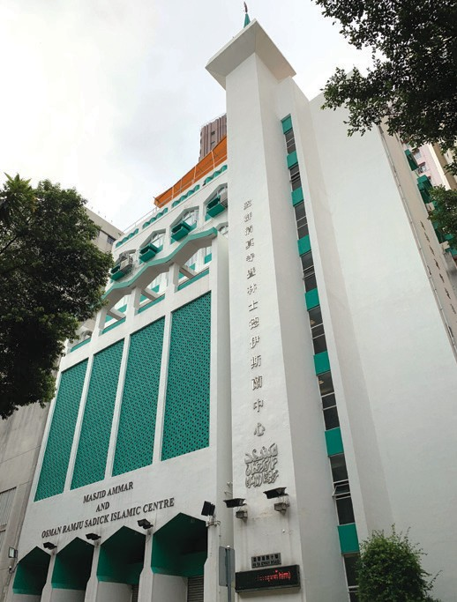  The Masjid Ammar and Osman Ramju Sadick Islamic Centre today | ˙Indicate the religion that the building belongs to.  ˙Indicate the ethnic group that introduced this religion to Hong Kong.  ˙Indicate the architectural feature(s) of the religious building by using text or drawing.  ˙Indicate the features of the environment  / community near the religious building.  ˙How similar do you think the religious building is to its original appearance after completion?  Extremely similar to the original appearance  1  2  3  4  5  6  7  8  9  10  Extremely different from the original appearance

With reference to your observations during the visit, do you think there is cultural diversity in Hong Kong? Illustrate your answer with an example you have seen during the visit.

172

Observing cultural diversity in Hong Kong from different ethnic groups and their religious cultures

Targeted Group: Junior Form Students
Duration: 35-70 minutes (depending on the number of students involved)
Related topics: The Growth and Development of Hong Kong until the end of 19th Century / beginning of 20th Century

Objectives:
The pre-requisites for the lesson are:
1.knowledge on different ethnic groups’ contribution to Hong Kong; 2.knowledge on the religious faiths related to different ethnic groups; 3.observation on the co-existence of Chinese and western cultures.

At the end of the lesson, the students should be able to:
- understand the cultural inclusiveness of Hong Kong through their enquiry on different ethnic groups’ contribution to Hong Kong;
- understand the cultural diversity in Hong Kong by observing the peaceful co- existence of different ethnic groups in Hong Kong.
By summarising students’ report, the teacher concludes the cultural diversity in Hong Kong.
10
Minutes
Students in groups are to report their findings and observation during the trip, and to encourage their reflections on the followings (Worksheet 4/5):
•How did the government respect different ethnic groups and their cultures?
•How did local Chinese community accept and live in harmony with people from different places and cultures?
25-60
Minutes

Duration
Content

173

In Pursuit of Aspiration – History of Different Ethnic Groups in Hong Kong and their Contribution to the Development of Hong Kong

References

丁新豹主編：《香港歷史散步 ( 增訂版 ) 》( 香港：三聯書店，2014 年 )

丁新豹、盧淑櫻：《非我族裔：戰前香港的外籍族群》( 香港：三聯書店，2014 年 )

Paul, O’Connor, Islam in Hong Kong: Muslims and Everyday Life in China’s World City, Hong Kong: Hong Kong University Press, 2012.

The Hong Kong Catholic Cathedral of the Immaculate Conception
http://cathedral.catholic.org.hk/

The Church of Christ in China Hop Yat Church
https://hkgc.hopyatchurch.org.hk

SKH St. Mary’s Church
http://dhk.hkskh.org/

SKH St. John’s Cathedral
http://www.stjohnscathedral.org.hk/

St. Margaret’s Church
http://smc.catholic.org.hk/

A Study of Cemeteries for Ethnic Minorities in Hong Kong, The Lord Wilson Heritage Trust
https://www.lordwilson-heritagetrust.org.hk/en/projects/project_listing/project_details/10- 207.html

Hindu Association Hong Kong
http://www.hinduassociationhk.com/

Khalsa Diwan (Hong Kong) Sikh Temple
http://www.khalsadiwan.com/

The Incorporated Trustees of the Islamic Community Fund of Hong Kong
http://www.islamictrusthk.org/
Extremely different from the original appearance

